PLYMPTON TOWN PROPERTIES COMMITTEE
Minutes, February 7, 2024, 2023, 6:30 PM

MEMBERS PRESENT: Nancy Butler, Ross MacPherson, Colleen Thompson, John Traynor, Mark Wallis,
Jon Wilhelmsen (Chair)
GUESTS PRESENT: Recreation Commission members Angelo Boccalini and Mark Reilly
NOTES:
- Participants are referred to by their initials. LD refers to Town Administrator Liz Dennehy. DP refers to Dan Pallotta.
- When possible, action items will be noted in BOLDED letters.
- “We” may refer to this committee, but it may also refer more broadly to the Town as a whole.
- We could not access the Dillon Room. The meeting was moved to the upstairs conference room in the Town House. This was noted on the police station door.
JW opened the meeting at 6:43

- FIRE STATION PROJECT / TOWN COMPLEX INFRASTRUCTURE – DP, JW and LD met this morning to make sure that all is on track to get the county ARPA funds. DP will continue to work with LD to put together a plan, with a well-written narrative, ready for submission in early March. The plan will request $260-$300k. DP will speak with his contact in County Treasurer Tom O’Brien’s office to seek a quick answer. We will be ready to seek additional funds should they become available.
DP has Cushing and Sons lined up to do the well drilling. MW asked about procurement procedures. DP is knowledgeable about the requirements and will make sure that this is done correctly. Engineering work is done under Well Procurement guidelines.
DP is following up with Context to get new drawings/pictures and will get the cost estimates updated. We expect to have DP and Context present at our next meeting.
DP told JW that the septic system is not an even swap. The number of people may be the same, but part of the formula is based on the square footage of the buildings. A larger building means a larger septic system.
- UPDATE/BUILDING NEEDS – RECREATION COMMISSION
- New Pole Lights - The new poles are 70’ tall, buried 9’. The poles will have baffles and the lights will shine straight down. The main concern is getting electricity to the new lights. He asked when the trenching would be done. We should have the design and timing from the engineer soon. MR said that they are meeting again with CPC next week. They have moved ahead to begin the excavation work and will move ahead with the installation of the poles. They hope to have the lights installed in June, with any extra funding coming through the Special Town Meeting portion of the annual Town Meeting in May. TPC confirmed that the electricity for the field lights will be coming from the library and will be part of the trenching for the new water lines. If we know what is going into the trenches, we can just move from pole to pole with the trench and wire. We need to know what size conduit is needed. MR said that the spring baseball season begins in April. They don’t want to have any open trenches when the players are running around the fields. JT asked if there will be any water needs. JW said that the supply pipes for future irrigation needs will be installed when the trenches are open. The plan will be for both water and electricity to be accessible at a single “master” pole. There was some discussion about the cost of running the lights – about $5/hour – and how the utilities are paid for the various buildings. JT will investigate the utilities question.

- Other Plans for Hoyt Fields – After the spring season is over, and the lights are installed, the field will be reoriented, fenced, and a walking path will be created around the fields. The fencing will be black, and in some areas consist of removable netting. RecCom is talking with Rob Firlotte to determine the best materials for the paths. He does not want stone dust because that is difficult to maintain. TPC suggested asphalt millings.
- Dennett and Jason Park Fields – AB reviewed drawings of actual and proposed soccer fields (see pages 4-9). They will continue to put RecCom funds into refurbishing and maintaining the fields. One problem is that the town does not have a mower designed for working on athletic fields. Without a bagger, the mowers leave clumps of grass which are disruptive to playing and dangerous to players. There was some discussion about the proposed tractor for the Highway department. This machine has the capability to use attachments for use on these fields and, as a bonus, equipment that is made for proper cleaning of snowy sidewalks. Harry Jason will eventually need irrigation installed. JW said that next year we will put together a comprehensive professional plan for Harry Jason. This plan will include fieldwork, water and electric systems, snack shack, cost estimates, etc. It will also be planned so that the various pieces can be implemented in phases.
The Dennett dugouts need covers to provide shade and shelter. This should be fundable through this year’s budget. RecCom will talk to the Dennett School Committee about this.
Additional Discussion – MR noted that dogs will no longer be allowed on the Dennett or Hoyt fields. Not all dog owners are good at cleaning up after their dogs. Some are good at using the poo bags, but there are issues with the full trash cans and children playing in fields that have excrement remainders present. The answer is for the town to create a fenced dog park that is large enough for a dog to get a good run. There was some discussion about the basketball court lot since plans are to move that to the town complex. That may not be large enough and may have some issues with neighbors and parking. Another option is the land on Center Street that is part of the Harry Jason gift but across the street from the playing fields.
The RecCom will need a warrant article to refill their revolving fund.

RecCom left the meeting at 7:30.
- MINUTES FOR APPROVAL – No minutes ready at this time.
- NEXT MEETING – Thursday, February 22, 2024. JW will follow up with LD to arrange a meeting with the town financial officers.
NOTE: NO OTHER AGENDA ITEMS WERE DISCUSSED.
The meeting adjourned at 7:45
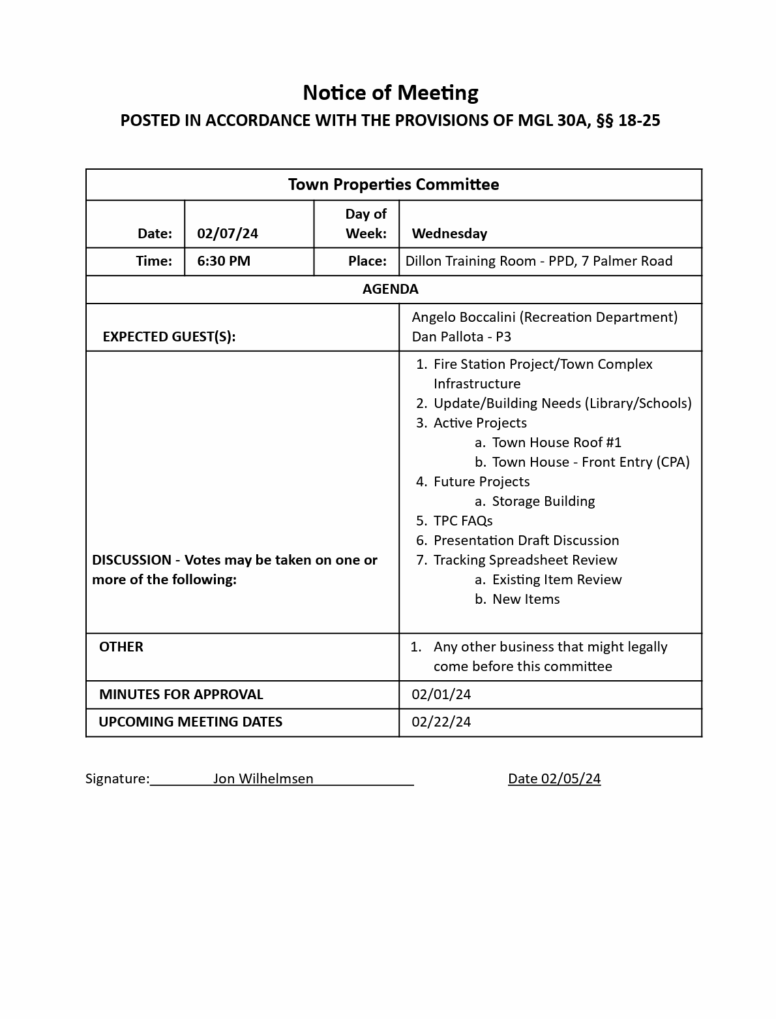
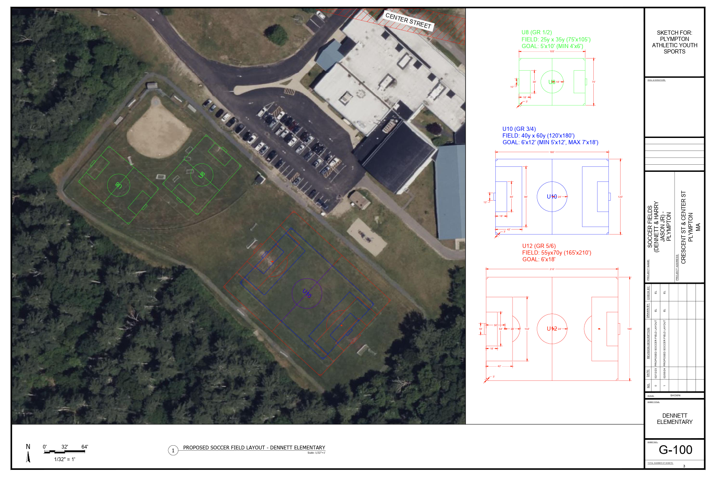
Plympton Soccer Fields #1a
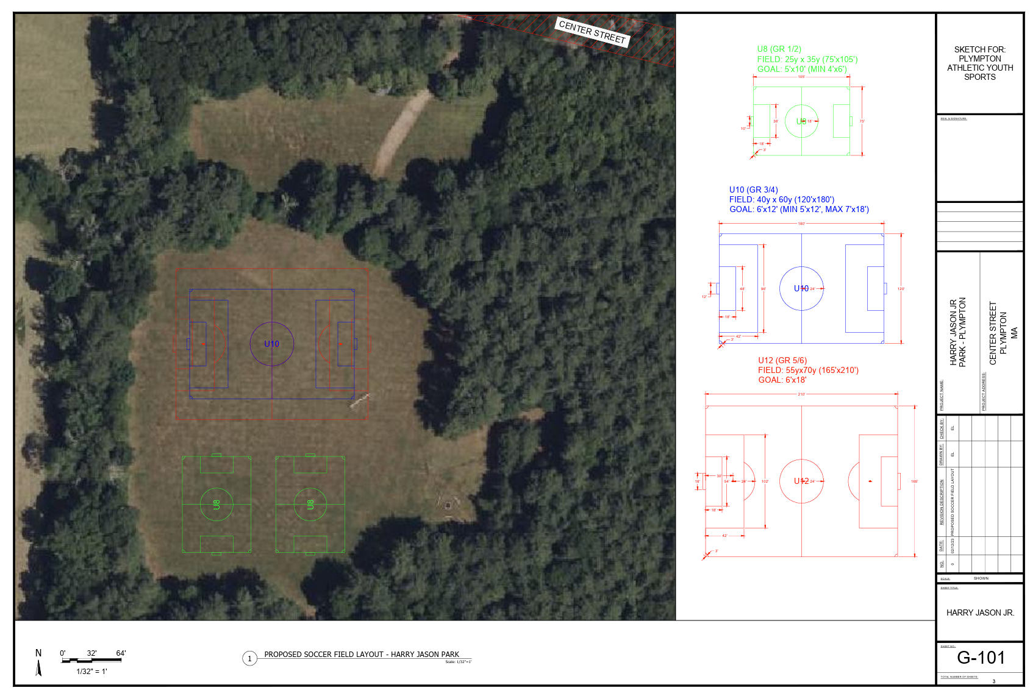
Plympton Soccer Fields #1b

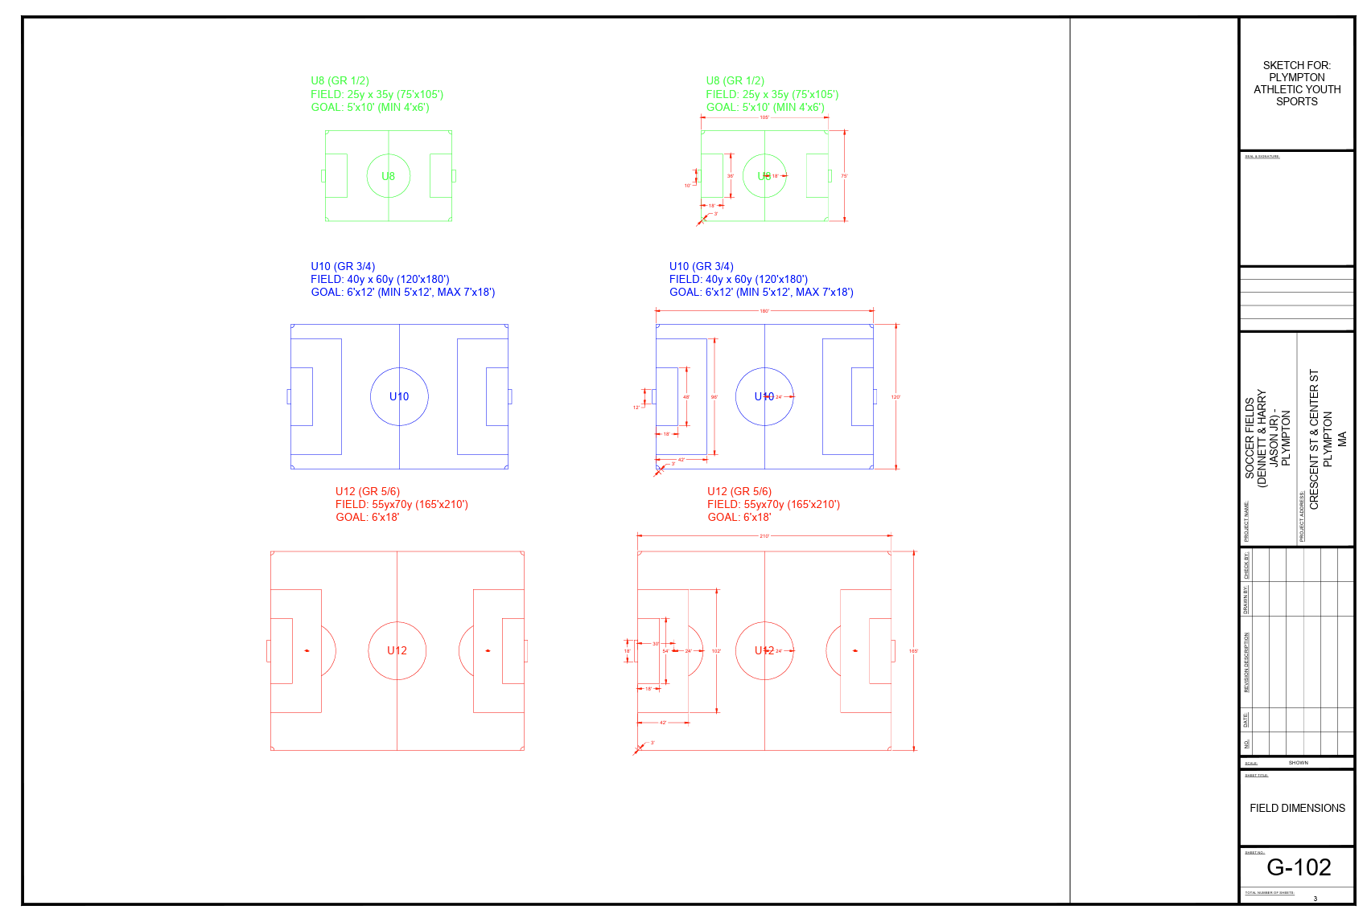
Plympton Soccer Fields #1c

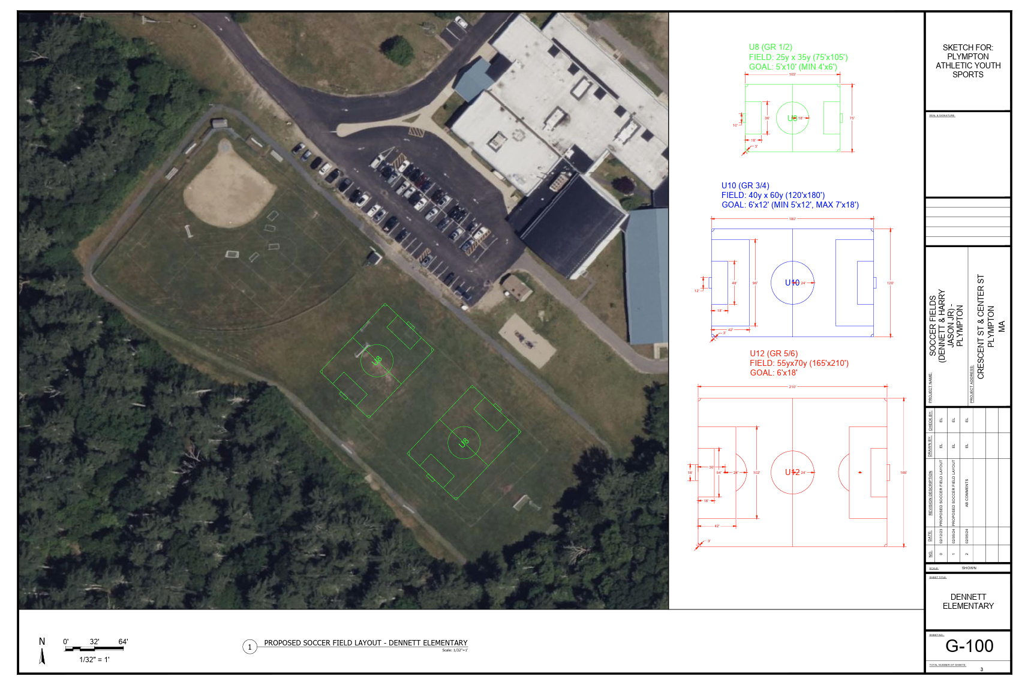
Plympton Soccer Fields #2a

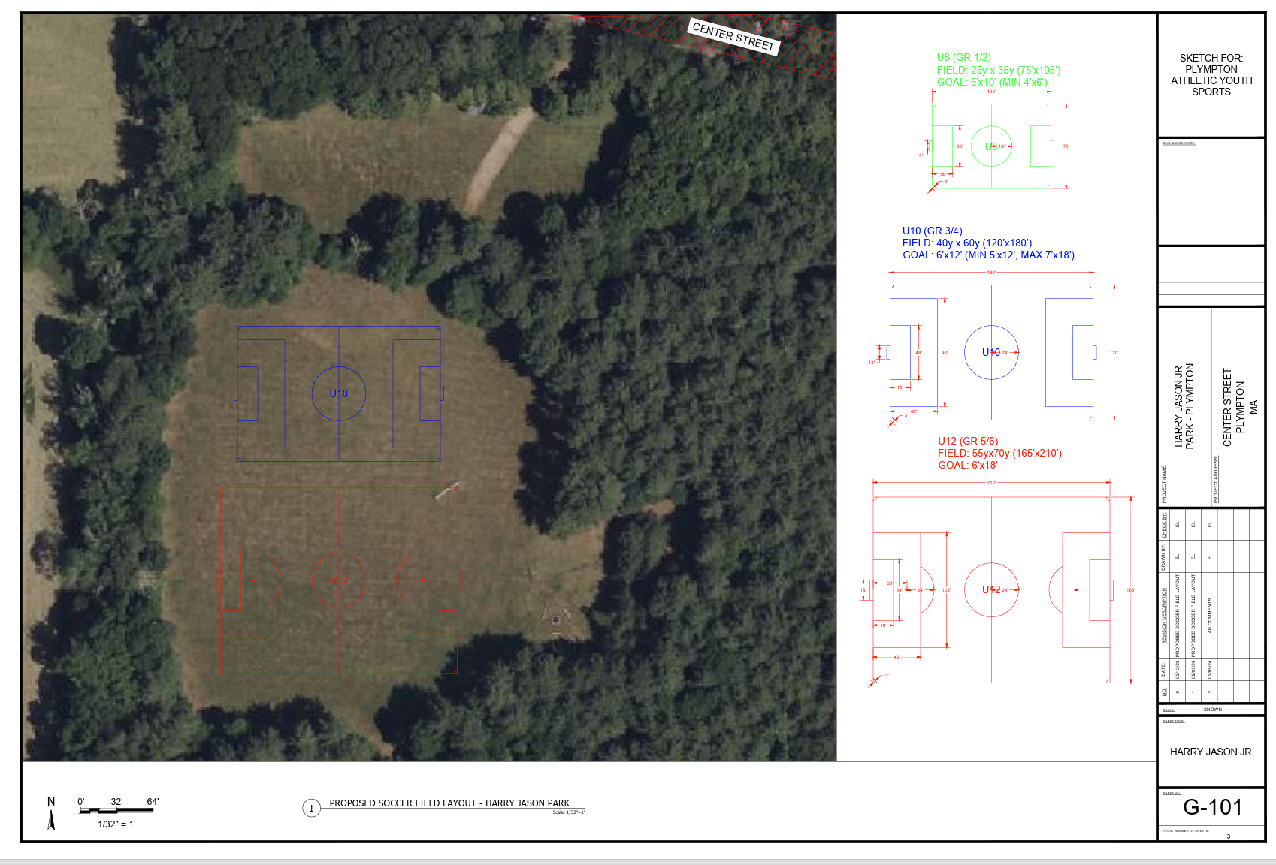
Plympton Soccer Fields #2b

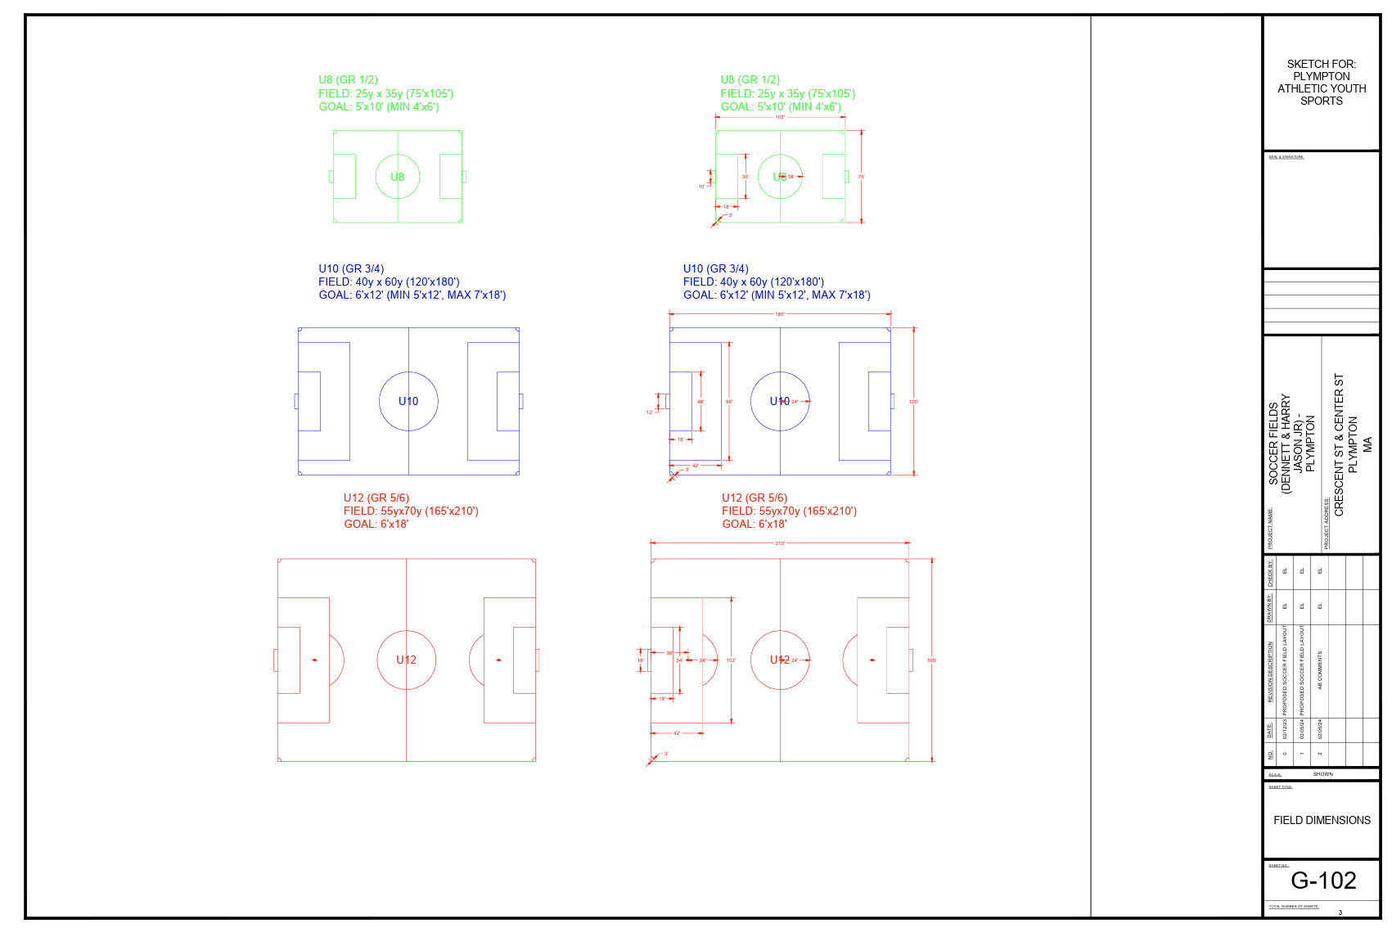
Plympton Soccer Fields #2c

