PLYMPTON TOWN PROPERTIES COMMITTEE
Minutes, November 9, 2023, 6:30 PM

MEMBERS PRESENT: Nancy Butler, Ross MacPherson, Colleen Thompson, John Traynor,
Jon Wilhelmsen (Chair) ABSENT: Mark Wallis
GUESTS PRESENT: Dan Pallotta (P3) via Zoom

NOTES:
- Participants are referred to by their initials. LD refers to Town Administrator Liz Dennehy.
- When possible, action items will be noted in BOLDED letters.
- “We” may refer to this committee, but it may also refer more broadly to the Town as a whole.

JW opened the meeting at 6:35.

- FIRE STATION PROJECT/TOWN COMPLEX INFRASTRUCTURE – (See pages 4-12) “Request for Site Exam/Pumping Test Proposal…” from Peter Dillon of Geoscience to Michelle Regon, MADEP.
DP said that we will need to add an article to the 2024 TM warrant to create the Zone 1 for the well site. This is a usual process done in other towns with public water supplies. It’s been a slow process, but a lot has been done. Having Peter Dillon has greatly reduced the cost of the well project. The guestimate for the cost of digging the wells is less than $50k.

The next step is to work with Grady to create a plan for getting access to drill the well, getting the water back to the TH and the other buildings, and getting cost estimates to make sure that we are within the time frame required for the ARPA funds. This should be done by February 1, 2024. DP will take Grady’s plan and make it clearly understandable for the public. At our next meeting on November 30th, DP will have a proposal for Grady to do this work to create the estimates. JW confirmed the need for a master plan to include everything (electric conduits, water and sewer lines, things that will be done in the future - clearly labeled “For Future Use”) to limit redundancies in the work. We only want to dig things up once. The plan should include everything, and we can then determine when to implement the various parts.

NB asked about the CPC project for lighting on the ballfields. TCP/RM will be involved in that project.

DP doesn’t think we need any more design work on the fire station, but we will need to have the estimates upgraded to the current timeframe. DP will work with Jeff Shaw of Context to get this done. The good news is that construction has stabilized and shouldn’t go up much in cost.

DP exited the meeting at 6:55.

- PUBLIC WATER SUPPLY ISSUES AND CORRESPONDENCE – See #1 above and pages 13–18: correspondence from BOH Administrative Assistant C. Ferguson and this Committee’s response.

- LIBRARY/FIRE STATION SEPTIC ISSUES – The new septic is in place.

- Other Active Projects – Not discussed.

- Police Station Update – Not discussed.

- Future Projects
a. Town House Front Entry - JW and LD met with the Community Preservation Act Committee
(CPC). The project as originally planned would cost $190k. The project has been reduced to
just the door for $40k and perhaps the steps and railing. They will go back to CPC in December
with a breakdown of the project parts with estimates.
b. Storage Building – Not discussed.

- TPC FAQs – Committee members were asked to think about this for the next meeting.

- Tracking Spreadsheet Review – Not discussed.

- OTHER DISCUSSION
a. Ball Field Lights – Total cost of project should be around $50k with CPA funds paying for the
supplies. PAYS will do fundraising for the electrician and will use donated labor for the trenching
and setting of the poles. They will work within the Town’s Bylaws for dark sky lighting.
b. There was some discussion about hopes for future projects on the Town Complex.
c. Financial Concerns – There was some discussion about the timing of the various projects,
planning within the Capital Account so that the monies have time to build rather than being
depleted annually, the State’s DOR recommendation that towns keep their debt level even from
year to year, and thinking of ways to be creative with funding.
d. JW will arrange with various groups and departments for their annual visit to a TPC meeting to
discuss needed and hoped for projects.

- JT moved that the minutes from the 9/21 meeting be approved as written. NB seconded. All aye.

- The next meeting will be scheduled for November 30th.

The meeting adjourned at 7:47

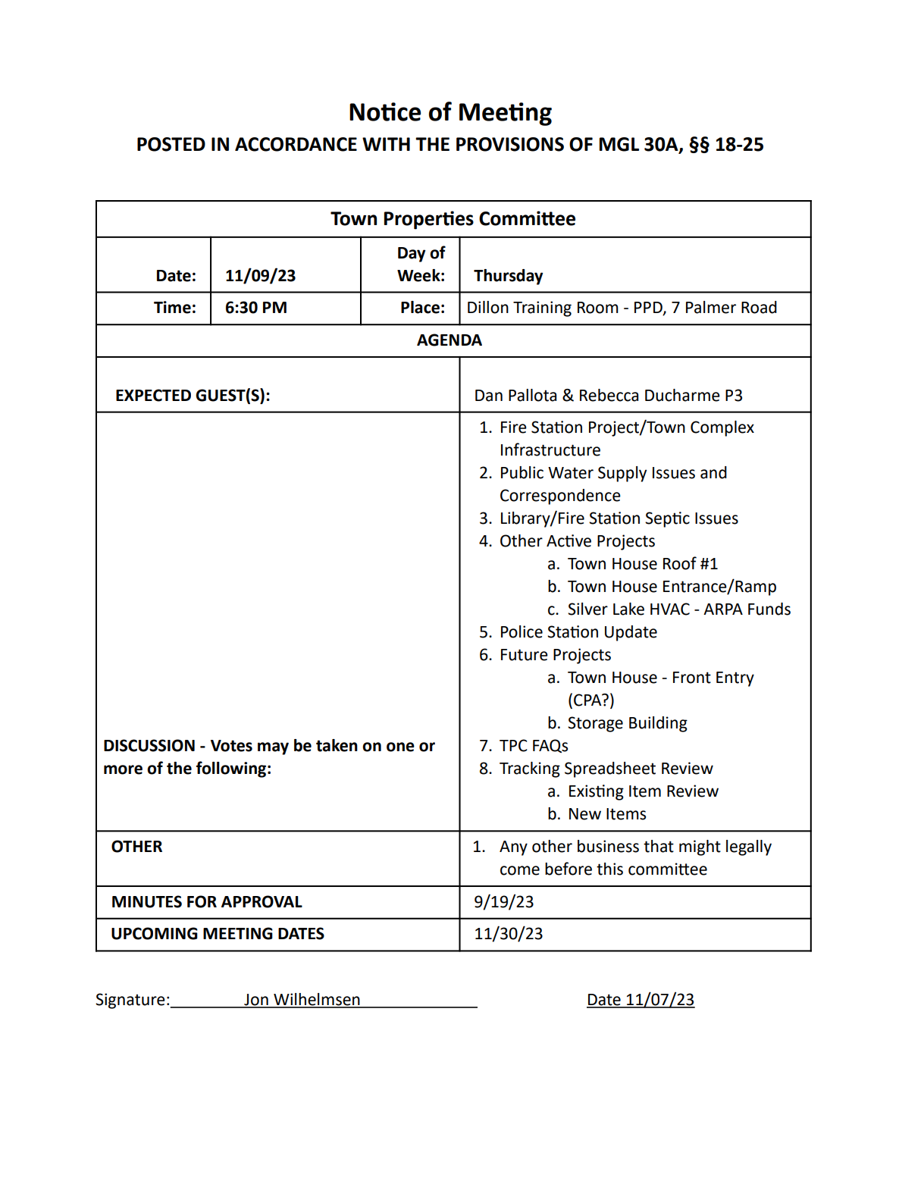
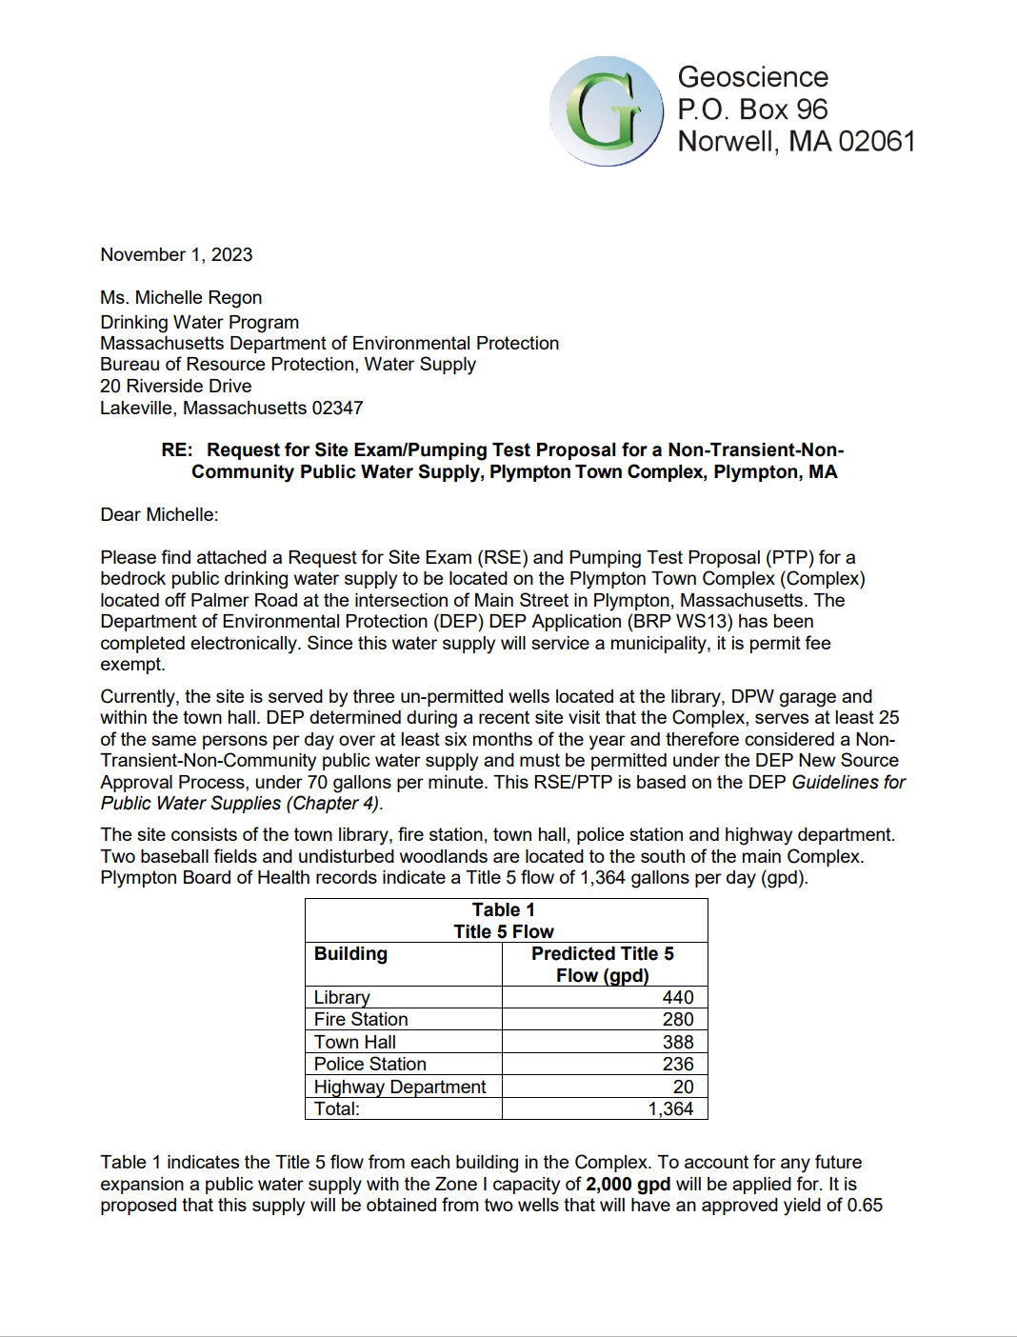
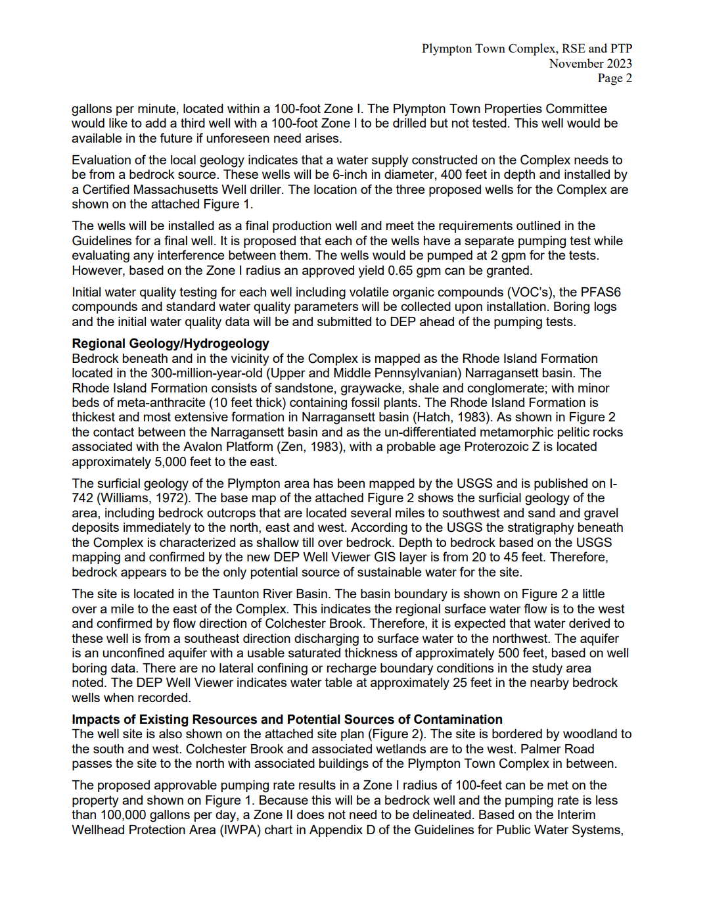
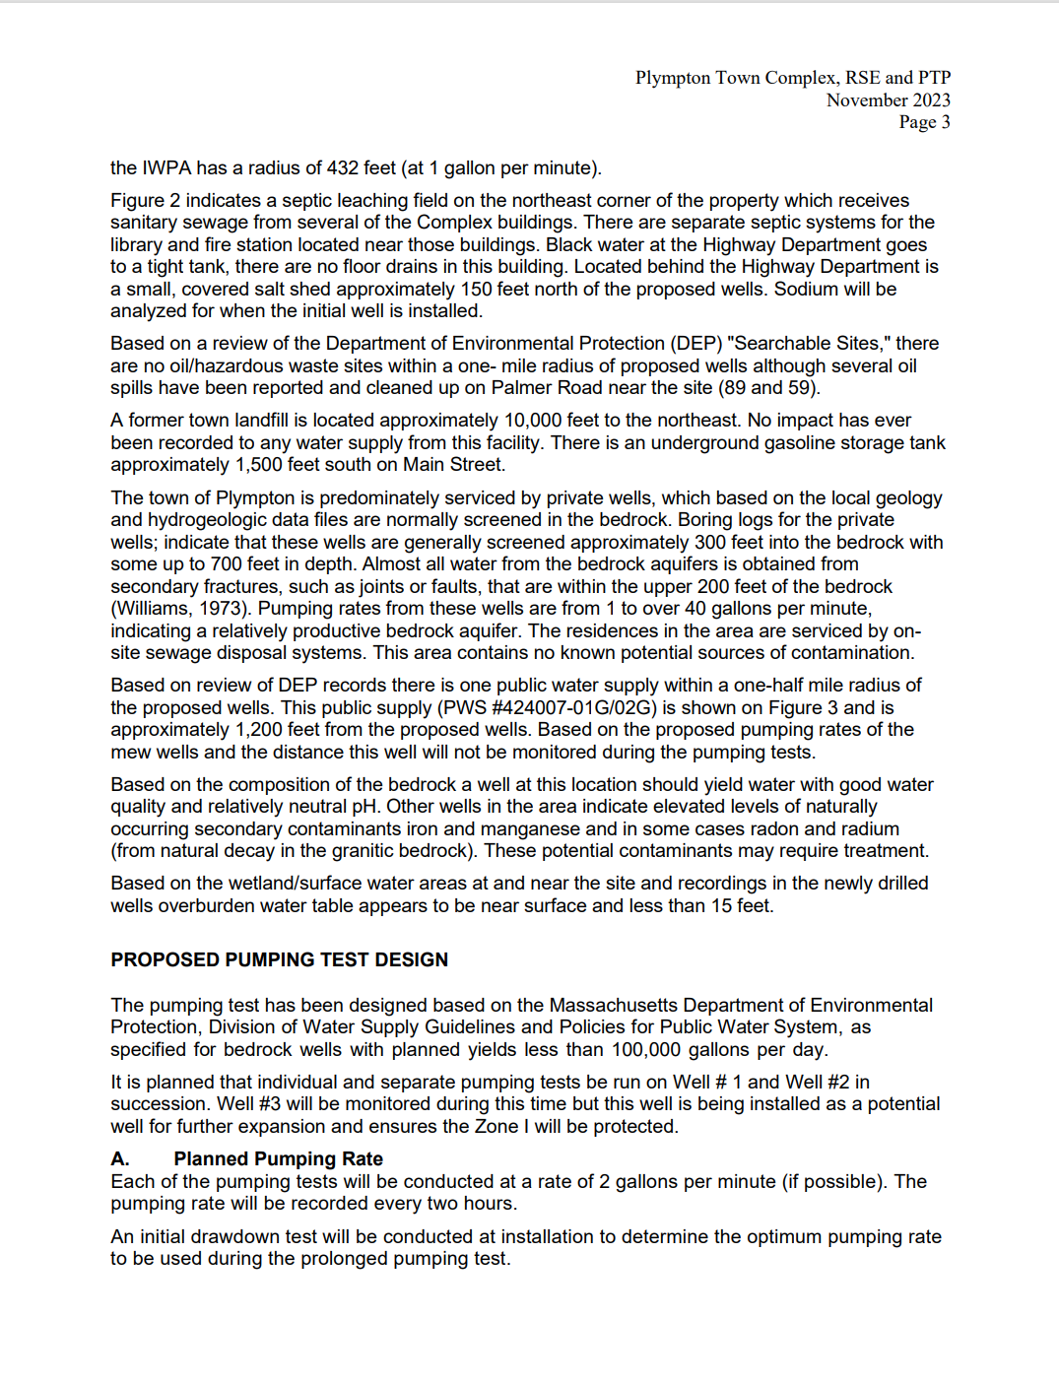
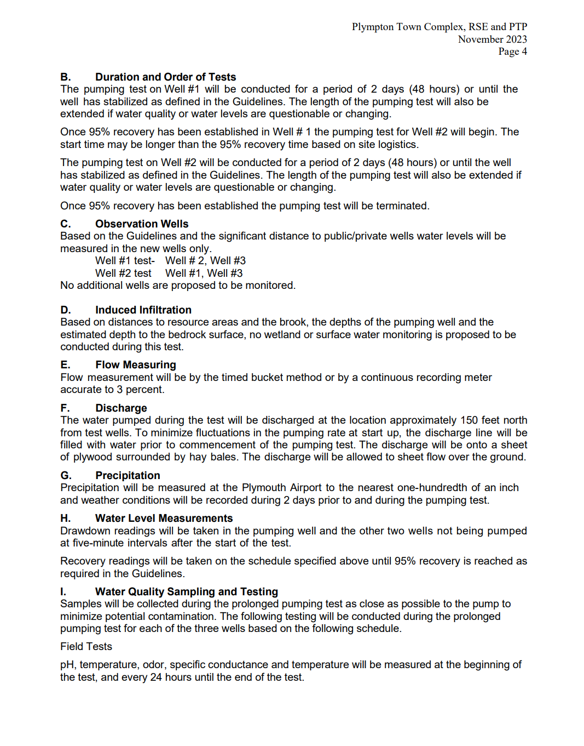

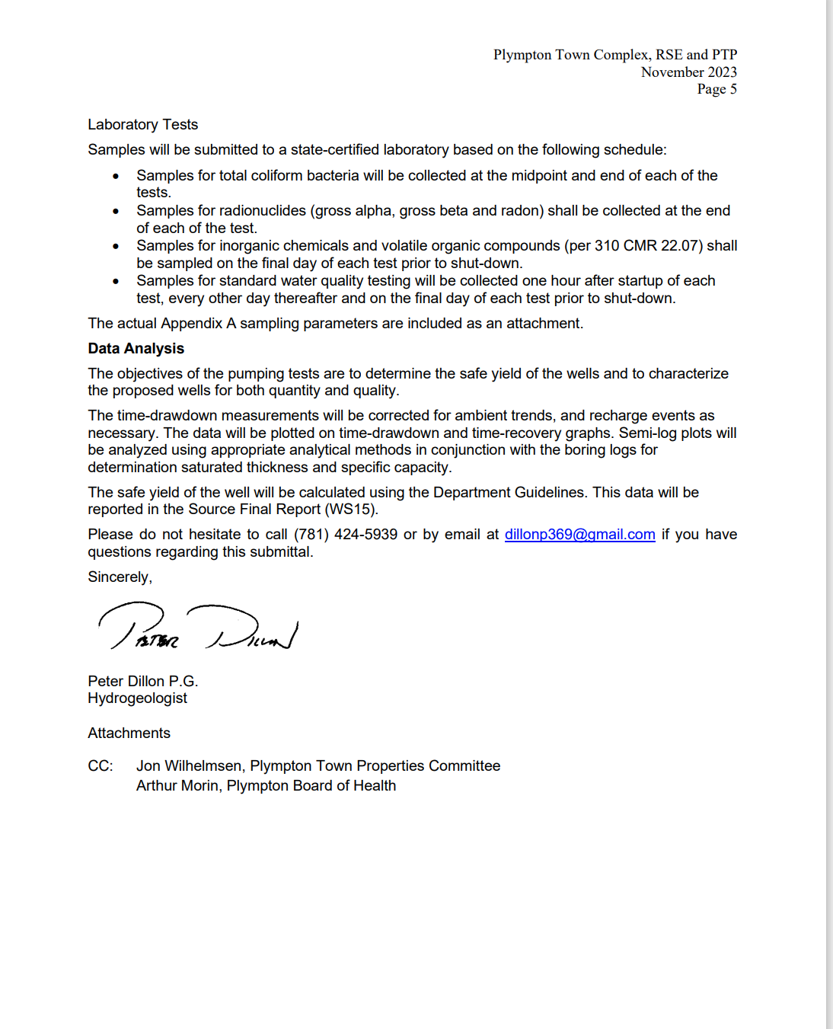

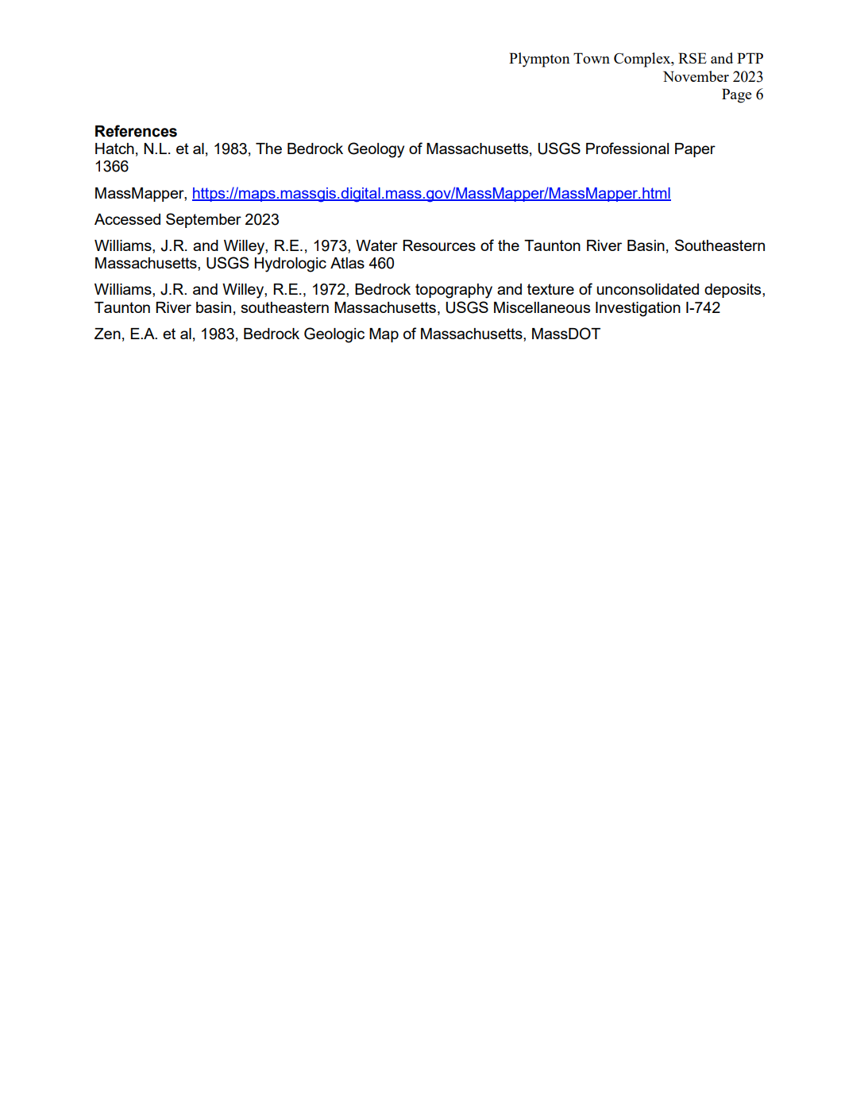
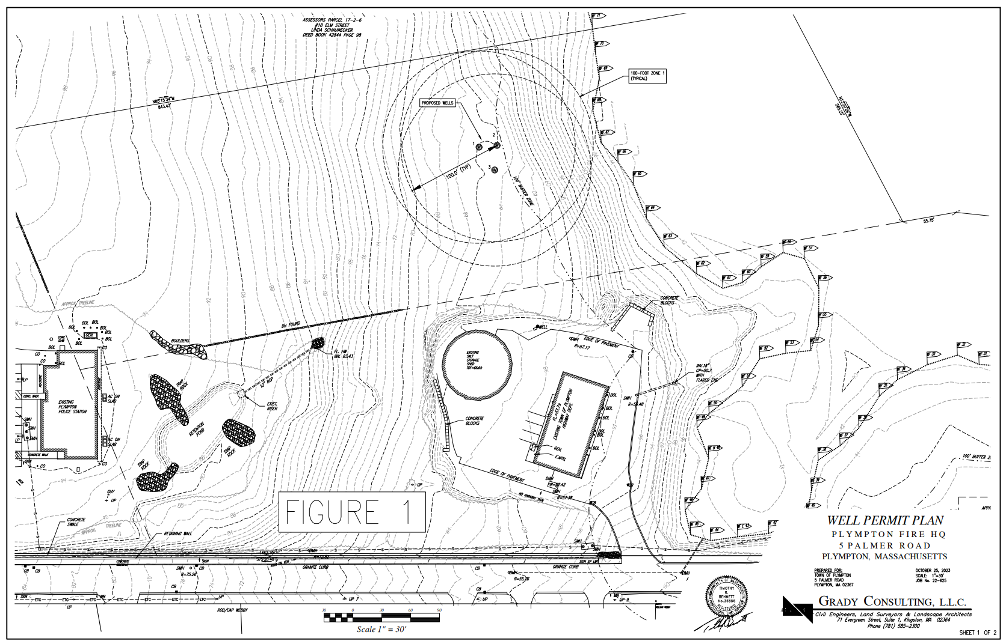
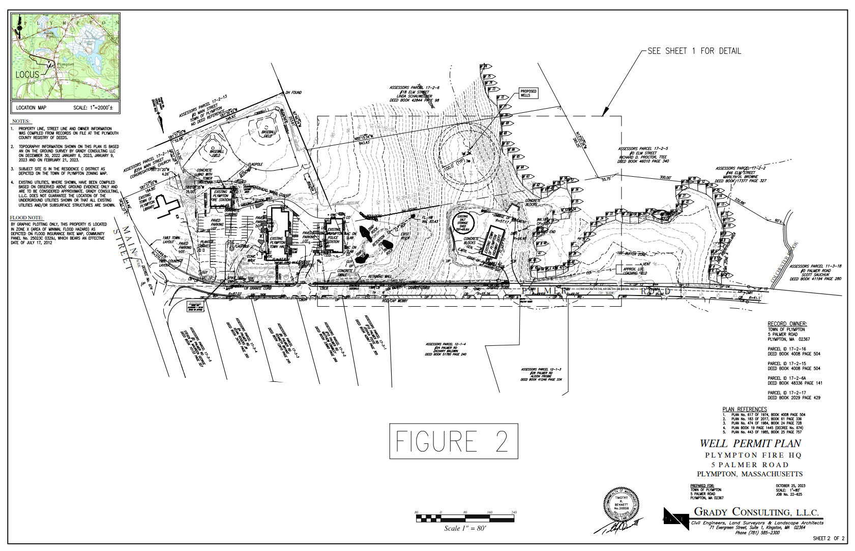
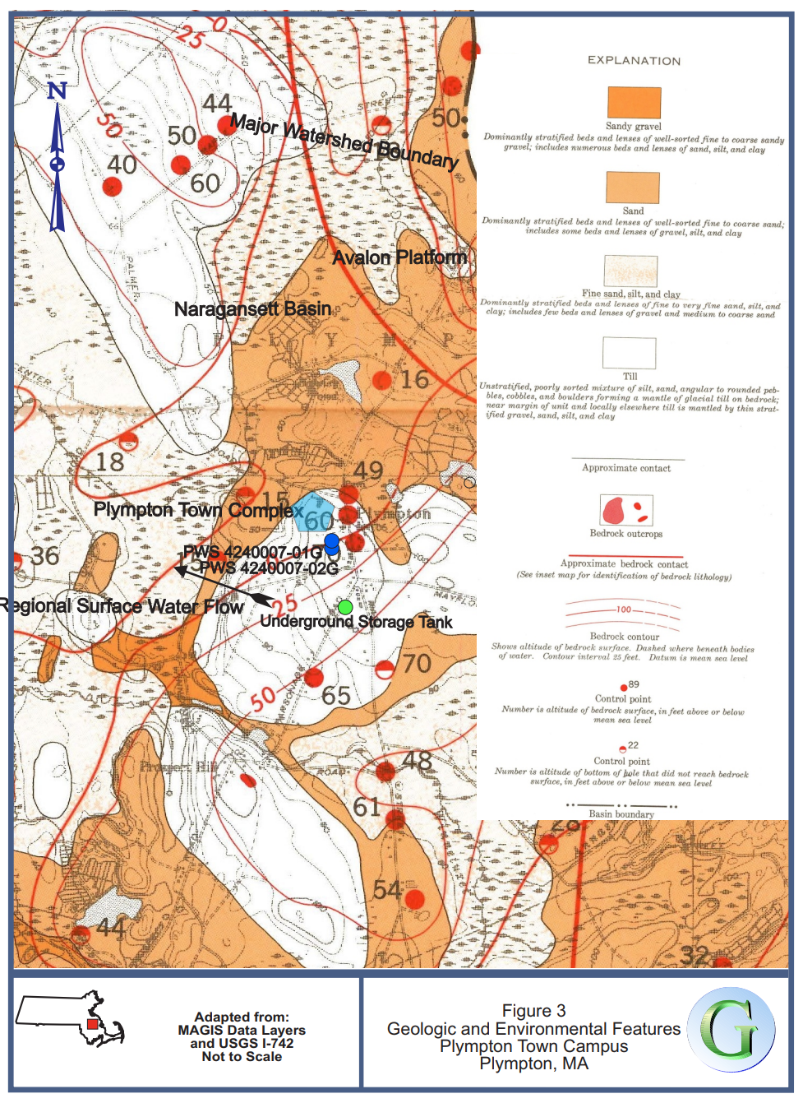
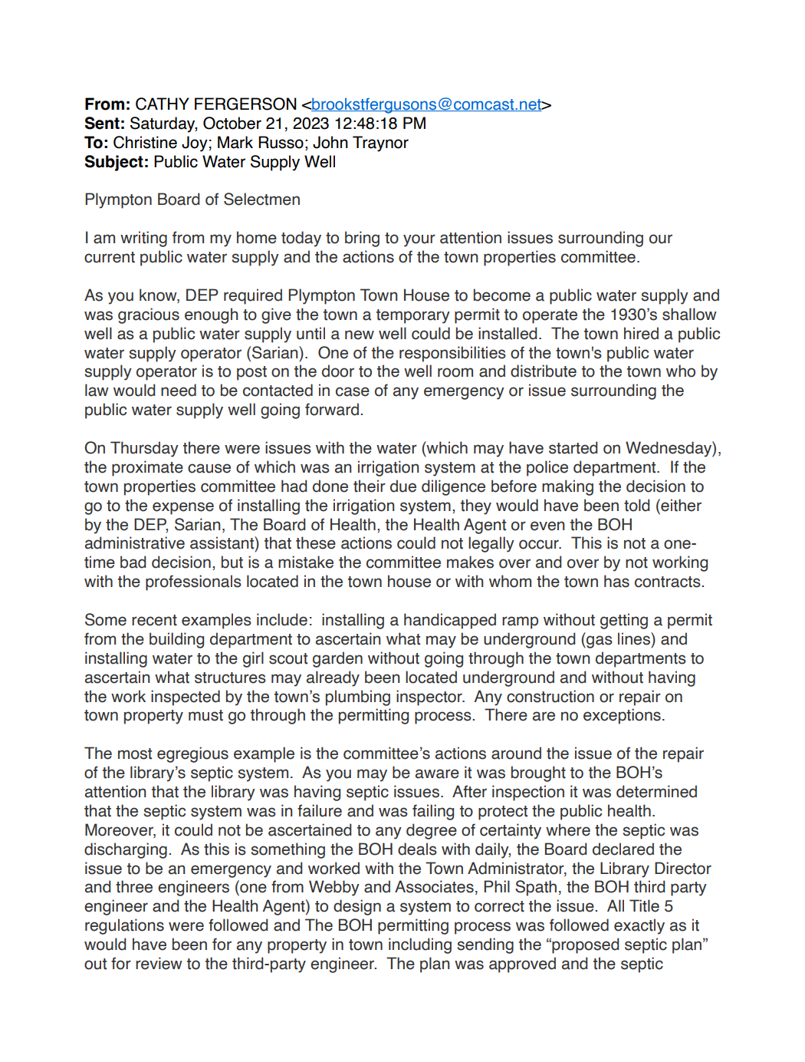
Cathy Ferguson emailed letter to BOS, page 1
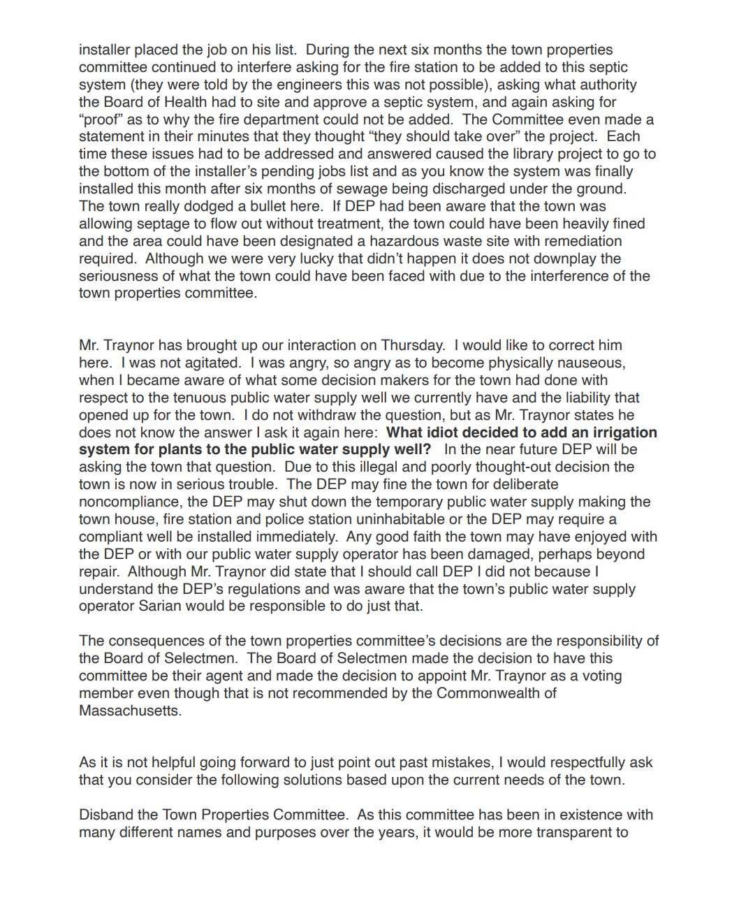
Cathy Ferguson emailed letter to BOS, page 2
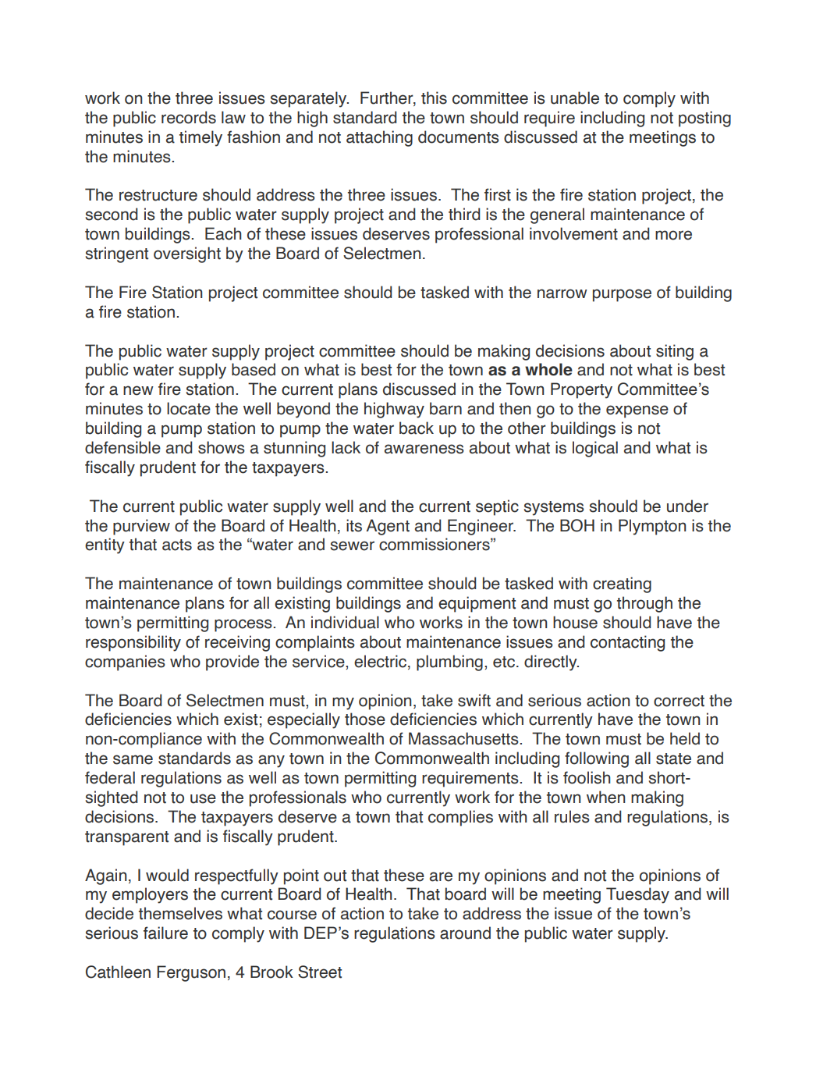
Cathy Ferguson emailed letter to BOS, page 3
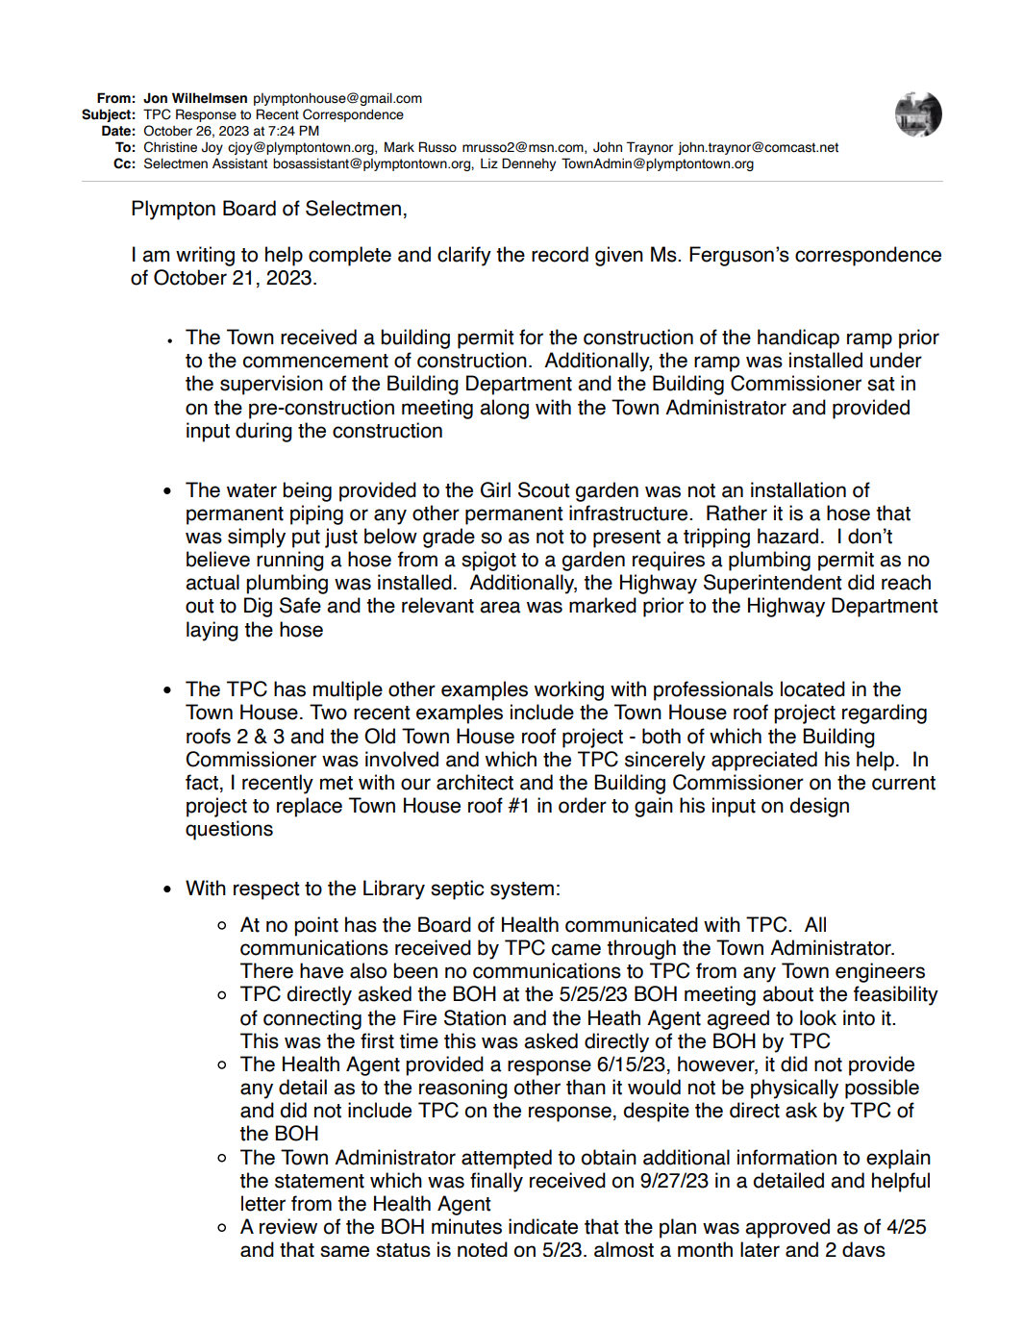
TPC response to C. F. letter, page 1
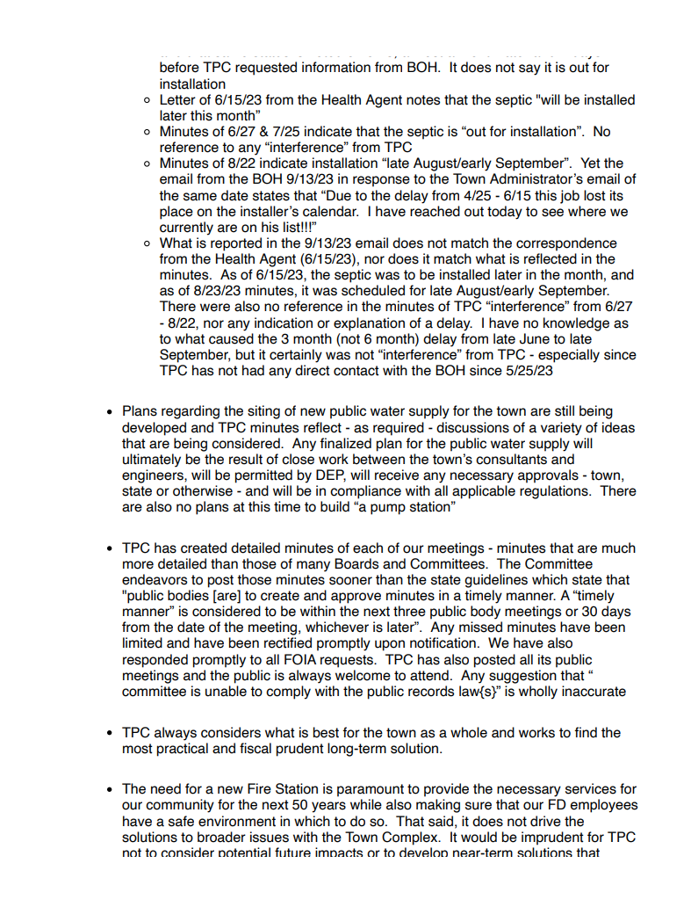
TPC response to C. F. letter, page 2
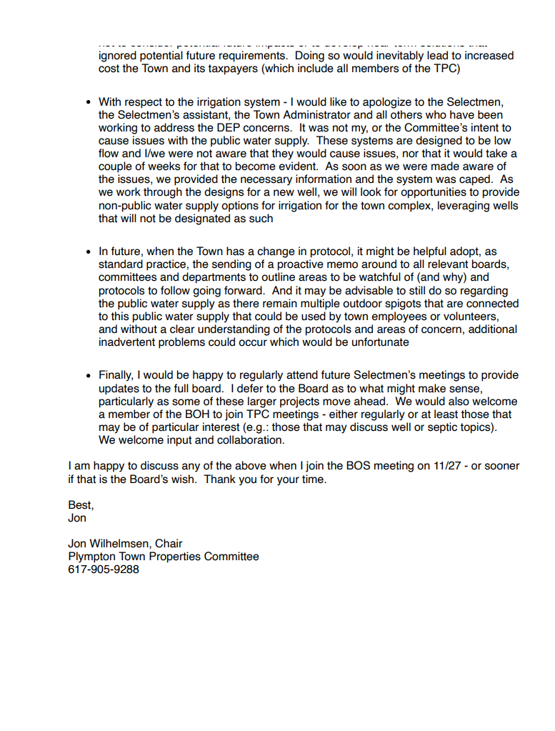
TPC response to C. F. letter, page 3

