PLYMPTON TOWN PROPERTIES COMMITTEE
Minutes, Thursday, December 14, 2022, 6:00 PM

MEMBERS PRESENT: Nancy Butler, Ross McPherson, Colleen Thompson, John Traynor,
Jon Wilhelmsen (Chair).
GUEST PRESENT: Library Director Mike Slawson
NOTES:
- Committee members and guest will be referred to by their initials in these minutes.
- When possible, action items will be noted in bolded letters.

OPENING – This meeting was held in-person in the Dillon Training Room of the Plympton Police Station. JW opened the meeting at 6:04

- FACILITIES REVIEW – PLYMPTON PUBLIC LIBRARY - The main purpose of this meeting is to discuss library projects that have been completed, are in progress and are possibilities for FY’24. See page 5 for the full list presented by Mike Slawson. The library trustees and staff are working on a long-range plan for the library. This is not only good for a successful library program; it is also necessary for the library to be eligible for state grants. This plan will be complete within a couple of months.
- Additional Notes on Completed Projects
- The HVAC drip plate alignment fix will be confirmed when the weather becomes humid again.
- The new lighting looks great and we are very happy with the project.
- Ramp bubbles repair will be at no additional cost.
- The newly i heat pump helped reduce the expense of the gas heat in November.
- Additional Notes on In-progress Projects
- The new shelves in the children’s room will be built by the Silver Lake Carpentry program. The cost will be for materials only.
- The carpeting will be done in conjunction with the shelves. The plan is to use carpet squares.
- Funding for the doors will come out of building maintenance with about $2,000 remaining from the front door fix.
- FY24 and Future Possible Projects
- Parking lot lighting – safety hazard – We need to figure out what we can do to alleviate the issue right away without incurring a large cost. Eventually the parking lots, entrances, and lighting will be done as part of the campus project. We don’t want to spend a great deal of money to do something that will need to be undone. Could the current lighting be made brighter, or a different type of bulb (high lumen LED) be used? RM will look and come up with an idea for our next meeting.
- HVAC evaluation – JW said that we intend to get the Green Community people back to assess the systems in the library and other town-owned buildings. Can we replace the two library A/C units with heat pumps, and have it funded by a Green Community grant? Regarding the new heat pump in the library, RM suggested that MS reprogram the schedule to keep the heat consistent for better efficiency and more comfortable heating. JW will follow up with Liz Dennehy about the Green Community grants. RM
said that replacing the heating with heat pumps will be an expensive project. Fortunately, it is likely that there is sufficient electricity to run the pumps since it is currently running the two A/C units.
- Carpet throughout building – All of the carpeting in the building is original. Despite cleaning it is dirty looking and stained. There is no asbestos in the building so there is no need for that remediation. MS will get a quote for carpet squares for each room. It may be necessary to phase the project. Also discussed was how to get the squares under the bookshelves. MS will check with other libraries to see how this type of job was done. Someone suggested that a moving company may be an option to move the books and shelves out and then back in.
- Building windows – All of the windows are in poor condition. The painters noted that the sills are rotted. This will be a very involved and extensive project which may also be eligible for Green Community funding. JW suggested that we get Habib Company to assess what needs to be done and how to do it. The old part of the building will be a restoration while the newer sections will be a straightforward replacement.
- New furniture (tables) – The furniture is outdated, heavy, and immobile, particularly in the older section and the children’s room. There are grants for this type of project and they will be pursued as soon as the long-range plan is completed. The hope is to keep the feel and ambiance created by the current furniture but have something that is more usable and movable.
- Tower inspection – As previously discussed, there are cracks in the supports that need to be reviewed.
- Basement leaking (one spot under emergency exit) – Likely an issue caused by the gutters.
- Water filtration – There is a cooler for drinking water, but the well water stains the fixtures. The water needs to be tested. RM asked if this building would be included in the new well system. This information may be available from the DEP review of the surveys and siting for the fire station. Hopefully this will be done in the next few weeks.
- Additional Library Discussion
- At their last meeting the Library Trustees decided that they would get public input for the long-range plan. This will be accomplished by (1) a postcard short survey sent to every household, (2) a UPC or QR code to a longer online survey, and (3) possibly a drawing to encourage people to respond to the survey requests. MS and the Trustees will also hold a meeting or two of “community stakeholders” – representatives from the BoS, schools, Town Properties Committee, etc. – to get their input.
- MS has applied for a Small Library – Small Community grant for funds to purchase new computers. The computers available for patron use are very old, very slow, and possibly not very secure. JW said that the library computers should be tied in to the Town IT plan for regular staggered replacement.
MS left the meeting at 6:50
- OTHER TPC DISCUSSION
- Dennett Solar - This must be completed within the next two weeks, or it will affect the PPA rate and push the project out even further. Liz Dennehy has contacted Town Counsel to encourage completion.
- Old Town House – Hoping to get some movement on this project soon.
- Facilities Review – JW will set up meetings with Police, Highway, Dennett, etc. to review any ongoing issues/maintenance and possible upcoming capital project needs. JW noted that although the town debt will be reduced in the next year or two, there will be other large projects that will need to be funded – SLRHS fields, Dennett roof, etc.

- Next Meeting – TBD
The meeting adjourned at 7:01.

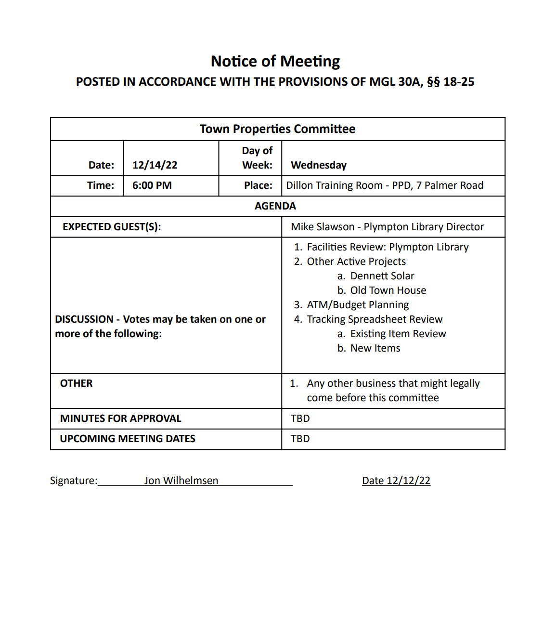

Plympton Public Library – Town Properties Committee Update FY23
Prepared by Library Director Mike Slawson

Projects Completed
$1522 - Hot water heater installation Complete
- 40-gallon hot water tank was installed in the ceiling above the circulation desk
$663 – HVAC drip plate alignment Compete
- Eldridge Plumbing was able to adjust the HVAC unit above the restrooms so it drained properly into the drip pan. This should solve the water leaking problems the Library has been having in this location.
$1650 – New lighting in adult fiction/young adult section Complete
- 8 new low profile LED lights were installed – 4 on each side of the building
$2,300 – Front ramp cracks and edges & non slip coating Complete
- Cracking and broken edges on the front entrance ramp the building has been repaired.
- Non slip coating applied
- Some small bubbles in the coating will be fixed in the Spring
In Progress
Carpet in children’s room – quoted at $3,600
New shelving in children’s room – approximately $3,500*
*to be paid partially from library gift fund
Other projects
$12,100 - New doors have been ordered for the children’s room (double doors) and the emergency exit
Repainting of parking lot lines – Highway Department
Heat pump installation Complete
- A new heat pump was installed in the basement that services the historic side of the building.
FY24 Possible Projects
- Parking lot lighting – safety hazard
- HVAC evaluation
- Carpet throughout building
- Building windows
- New furniture – tables
- Tower inspection
- Basement leaking (one spot under emergency exit)
- Water filtration

