PLYMPTON TOWN PROPERTIES COMMITTEE
Minutes, Thursday, January 26, 2023, 6:30 PM

MEMBERS PRESENT: Nancy Butler, Ross McPherson, Colleen Thompson, John Traynor,
Jon Wilhelmsen (Chair). ABSENT: None
GUESTS PRESENT: None
NOTES:
- Committee members and guest will be referred to by their initials in these minutes. LD refers to Town Administrator Liz Dennehy.
- When possible, action items will be noted in BOLDED CAPITAL letters.
- “We” may refer to this committee, but it may also refer more broadly to the Town as a whole.
- This meeting was held in-person in the Dillon Training Room of the Plympton Police Station.

JW opened the meeting at 6:34

- New Fire Station – It is possible that we will not be ready to recommend to the 2023 Town Meeting that this project move forward to the building stage. We may just look for more funds to create final drawings/complete building plans. If we have the plans completed, we will be ready to move forward when the interest rates and building supplies costs come down. We will also be ready to apply for grant monies or additional ARPA funding should these become available. If we meet with the town financial group after TM, we will have a better idea of what monies will be available and what will be needed for other projects. We don’t have to make this decision until mid-April so we will just put a placeholder on the warrant.

- Highway Department (HD) - Rob Firlotte (RF) was unable to be at the meeting but sent an email to JT delineating some of the needed equipment, building repairs, and other possible HD projects. JT gave committee members a copy of the email (see pages 4&5). Discussion points:
- RM agreed that it important to give the HD the right equipment to do their jobs.
- JT said that the Dennett has appropriated money for a new mower.
- The various groups involved in the use and upkeep of the Town fields need to get together to form one plan and schedule and, perhaps, help determine the funding source. These groups are the HD; the Town Properties, Recreation and Harry Jason Committees; and PAYS and CASA leaders.
- The Holt Field dugout needs a new roof. It is possible that this work could be done by PAYS volunteers, but those people should be focused on the sports programs, not the physical aspects of the buildings and fields. JT thinks this may be a good opportunity to install a long-lasting metal roof. CT suggested that maintenance of town facilities should be controlled by the Town so that the other groups don’t assume ownership. This helps to reduce confusion when other projects (fire station/community use) affect the area.
- Highway barn siding needs repair/replacement. RF needs to get accurate estimates, or we should hire Habib to do the estimates. We need a solid number and thorough understanding of the work that needs to be done. JT will talk to LD about this.
- RF wants a storage building on the town barn property. We need more information about the projected use of this building. Is this the best location for this? It is less expensive for the Town to build a larger building (likely at the Transfer Station) which can be used by multiple departments. HD equipment can be rotated seasonally.

- Dennett Solar – We almost have the final agreement worked out, but it’s not done until it’s actually signed.
- Old Town House – We are working on the project plans. When those are ready, the project will go out to bid. After the roof is completed – probably in April - we’ll deal with the mess inside. The complete roof project includes total removal and replacement of the roof and insulation, and repair/replacement of ceilings.
- Fire Station Toilet/Septic Issue – JW and LD met with the Board of Health Chair. The BOH will help, through their Health Agent, to chase down the companies that can make good recommendations about how to fix the problem. The BOH may have more clout when trying to get a response from the companies. We will not mill the pipes or spend funds on other remedies until we know exactly what the issue is and what the ultimate cure will be. The Health Agent is also an engineer.
- Other Discussion Points:
- There was some discussion about the SLRSD. They will likely be putting articles on the warrant for some capital projects. Both Halifax and Kingston are adding multiple housing units which will affect the schools.
- JW talked about upcoming increases in the SPEDs budget and other expenses for the Dennett (security/First Responders’ repeaters and radios, rooftop HVAC units, classroom floors, etc.). He will be meeting with Peter Veneto and Matt Durkee.
- JW wants to LD about the #1 (front) portion of the Town House roof. We need to make sure that the estimates are still valid. There was some discussion about whether this type of work could be funded by Community Preservation monies.
- BETA is working on the updated plans for the Town House entrance.

- Minutes – JW moved that the minutes for the past three meetings be approved as written.
RM seconded. The motion passed unanimously.
- Next Meeting – JW will schedule additional meetings so that we can meet with all of the departments/building heads. He will solicit available dates and schedule appropriately.
- Adjournment at 7:46

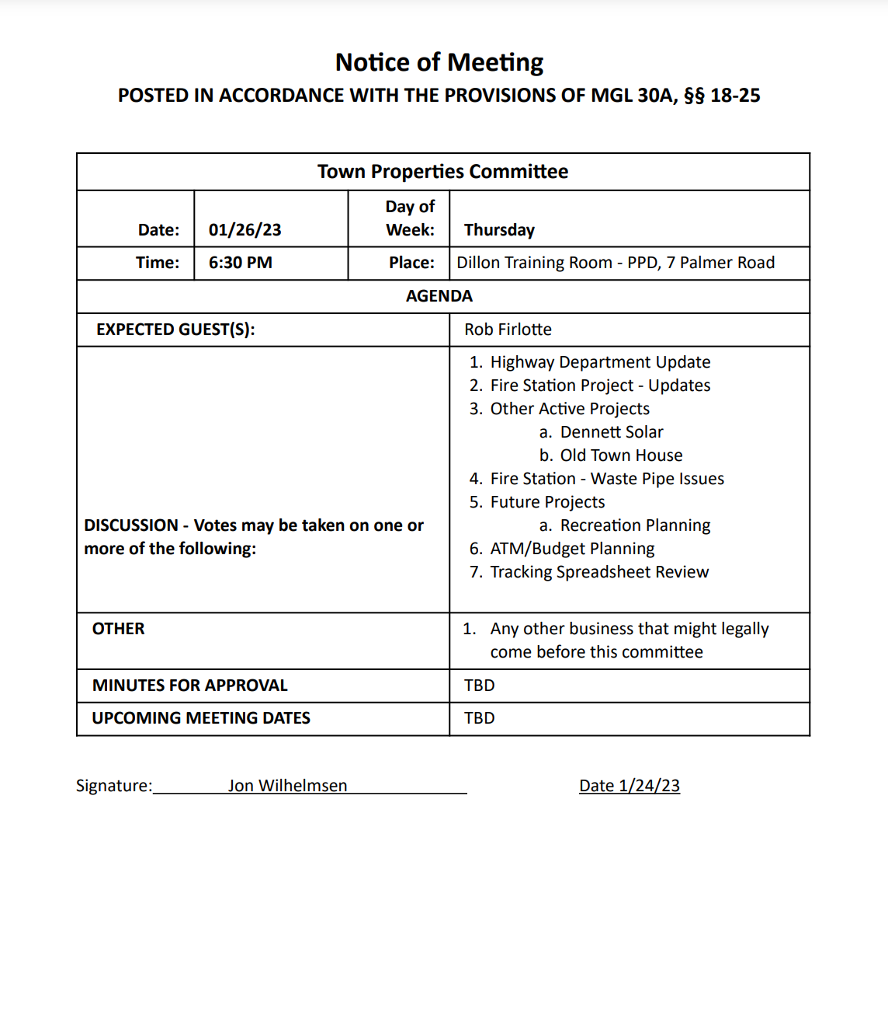
From: Highway <highway@plymptontown.org>
Sent: Tuesday, January 24, 2023 10:56 AM
To: John Traynor <jtraynor@plymptontown.org>; john.traynor@comcast.net
Subject: Town Properties Meeting
Hi John,
I have attached the quote for the tractor and attachments. The first attachment has the pricing for the tractor with three seasons cab, summer canopy, and suspension seat. Attachments for the tractor included on that list are as follows.
96" wide area mower to be used on the school athletic fields as well as Harry Jason Park. Five acres in total, which during the growing season has to be mowed at minimum once a week. This attachment will alleviate the use of our tired 90" land pride mower attachment that has been in use since 1998. It will also help to keep some hours off of the tractor that is currently running the attachment which is around 3,000 hours now.
48" snow blower to be used on the sidewalks, the town currently does not own one. When we do plow the sidewalks, we come in around two am and use a pickup truck to remove snow from the walk way depositing it in the roadway. Then we use two other trucks to jockey all the snow to the other side of the road. The loader is also required to do curbing returns. Then at the end we have to retreat the road area with salt, Very unconventional expensive and not the safest way to do it. This machine can safely and efficiently remove the snow and apply salt with just one operator at the end of a storm.
52" sidewalk broom. We currently borrow the Town of Halifax's in the spring when we can. Some years we are unable to sweep sidewalks because of this.
Fertilizer spreader, the town currently does not own a powered fertilizer spreader. Plympton owns a hand spreader that is used in the cemeteries. When we do any large scale fertilizing, we borrow Rick Burnett's spreader. That spreader is now close to ten years old and rotted. Last time it was borrowed it required repairs to be used.
The second attachment at the top contains the quote for four items. Listed as follows.
Drop spreader, used for salting the sidewalks after snow removal. The Town currently does not salt the sidewalks.
Ballpark renovator, used for maintaining the infield. This implement attaches on the front of the tractor and is used to remove weeds, maintain grass edging, and loosen soil. Currently this is done by volunteers.
Ballpark groomer, used for maintaining the infield. This implement attaches on the rear of the tractor and is used for dragging and leveling out soil. Currently this is being done by volunteers.
72” Flail mower can be used to help maintain Plympton's parks walking paths. Our current tractor and brush hog can do the larger areas but struggles on the smaller paths. Some of the paths are inaccessible with our current tractor. Ventrac is smaller in size, articulates and can mow sloped areas.
I have included the link https://www.ventrac.com/products/tractors/4520 so you can check out the machine, it's attachments and the things it can do.
On the subject of the front wall of the Highway Department I feel it should come in under the price of the roof. My guesstimate would be in the ballpark of seventy-five thousand.

Dry storage building on the Highway departments grounds. We have prior cleared a spot for 25x50 building. The building in discussion is proposed for dry storage only. It will be used to provide dry and safe storage for all of our seasonal equipment. This would allow us to keep everything indoors out of the weather locked up and secure. Our current storage build is a 10x30 truck body that was donated over 20 years ago by Mike Penetti. It was decommissioned from road use prior to be donated to the town, the condition of this has only deteriorated. The cost of this should come in less than $100,000.
I apologize for not being able to make the Town Properties committee meeting.
Thank you
Rob Firlotte
Highway Superintendent
23 Palmer Rd.
Plympton, Ma 02367
Tel:781-585-3703
Fax:781-585-6831
Cell:781-254-6991
NOTE: This is the first page of the equipment brochure and quote. That document is 26 pages long and has not been included in the minutes. The final cost would be dependent upon which attachments and accessories are purchased.

