PLYMPTON TOWN PROPERTIES COMMITTEE
Minutes Wednesday, March 3, 2022, 6:00 PM

MEMBERS PRESENT: Nancy Butler, Colleen Thompson, John Traynor, Jon Wilhelmsen (Chair).
GUESTS PRESENT: Fire Chief Stephen Silva, Todd Costa of Kaestle Boos Associates, Harry Weikel, Art Morin, Michael Jardin, plus one unidentified attendee
- This meeting was conducted on a Zoom meeting platform with members and guests
participating remotely. Members and guests will be referred to by their initials.
- ACTION ITEMS: In bold print

OPENING – JW opened the meeting at 6:02 p.m. by reading the Governor’s orders of 3/12 & 15/20 which allow this Zoom meeting as a temporary change to Open Meeting Law during the COVID-19 shut-down. The meeting will be recorded to provide public access.

- FIRE STATION Q & A – Led by Todd Costa. This is a difficult market to gauge. Prices are up 8-9% but escalation is now down to 6-7%. It depends on the size of the project, but smaller projects are costing more right now. TC met with KB’s primary estimators and learned that supply availability, lead time and labor availability are still driving costs up. This is bad but it will self-correct at some point. Now is a good time to do the preliminary work and design work so that the Town is ready to bid when prices stabilize.
TC began a PowerPoint overview of the state of the State regarding the construction costs of new fire stations. Unfortunately, the presentation was cut short due to technical difficulties. Some of the information that was heard includes:
- There is a big difference between the design, function, and firefighter safety of older stations versus newer stations. The Plympton station is basically a glorified garage designed for an on-call department with equipment that was sized much smaller than what is available today. Modern fire trucks do not allow for personnel to ride on the outside of the vehicle to travel to a call (see chart on page 3). Ambulances are now on truck, rather than van, bodies which increases the length of the vehicle. The current building has inappropriate mixed-use space, falls very short of OSHA requirements and the campus suffers from a dangerous entrance/exit situation. There are issues with firefighter health and safety, insufficient sleeping quarters and toilet/shower facilities, and gender equity. There is no proper clearance around the vehicles for personnel safety or even for use and maintenance. The only thing on the floor should be wheels and feet. This is not the situation in Plympton, nor can it be in this building. Storage should enhance, not impede operations. Current storage includes offsite facilities which could make restocking a critical issue for multiple calls.
- The committee asked if there are minimum requirements or standards for spacing. TC said that there are recommendations but not standards. You want to design a building that is appropriate for the municipality without overbuilding. One simple example of good design is to make the bay doors the right size (14’x14’) to reduce possible vehicle damage and so that the department does not have to special order expensive special-sized vehicles. CSS pointed out that when our vehicles return after a call, they must be left outside to decontaminate, remove and replace supplies and equipment, and maintain the engine. There is no room to do any of this inside the station. TC said that the usual clearance on all sides of a vehicle should be 5-6’ to allow free movement of firefighters and there should be equipment for the direct capture of exhaust. In our station the bumpers actually overlap!
- The committee said that we need to understand the cost of the Plympton-appropriate building. Is there a way for us to control design costs – maybe use other designs such as the new Sandwich station? TC said that there are many ways to control costs. The first step is to get the right designer who is familiar with the industry and help us effectively spend or save our dollars to build for the longest life of the building while being responsive to community needs.
- The committee reiterated that we are charged with the care of Town buildings. A feasibility study will clarify what we are looking for in a new station, if our planned site will work, and an understanding of the costs if we build now, in a year or in five years.
TC left the meeting at 6:33
- TRACKING SPREADSHEET REVIEW – JW reviewed the updated spreadsheet. He noted that the buildings/properties have been put in alphabetical order and color has been added to aid readability. See page 4.
- FINANCE MEETING UPDATES - JW and JT will be meeting with the FinCom on Monday. The meeting will be posted for TPC in case anyone else wants to attend.
- REVIEW OF POTENTIAL TOWN MEETING WARRANT ARTICLES – See page 5.
- ACTIVE PROJECTS
a. Town House Roof – documents are being created
b. Dennett Solar – contracts to be reviewed by town counsel again.
- FUTURE PROJECT – No updates
- TOWN BUILDINGS – No updates
- MINUTES – JT moved that the minutes for February 16, 2022, be approved as written JW seconded. Roll call vote: JT aye, CT aye, JW aye, NB abstain
- NEXT MEETING – TBD
- ADJOURNMENT – 7:04 p.m.

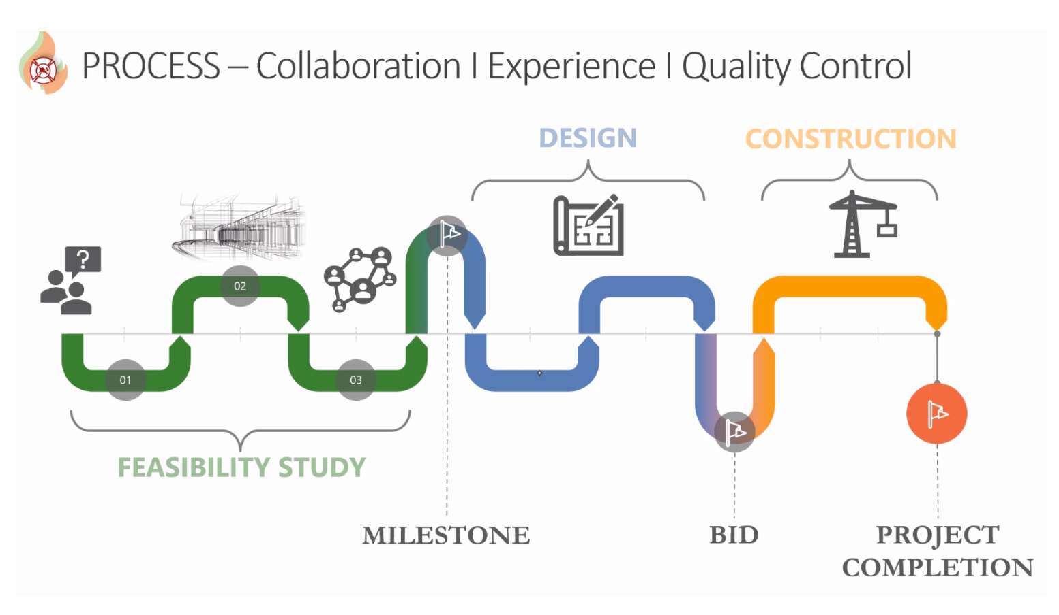
SAMPLE OF TODD COSTA PRESENTATION SLIDES
The PowerPoint presentation was discontinued due to technical difficulties.
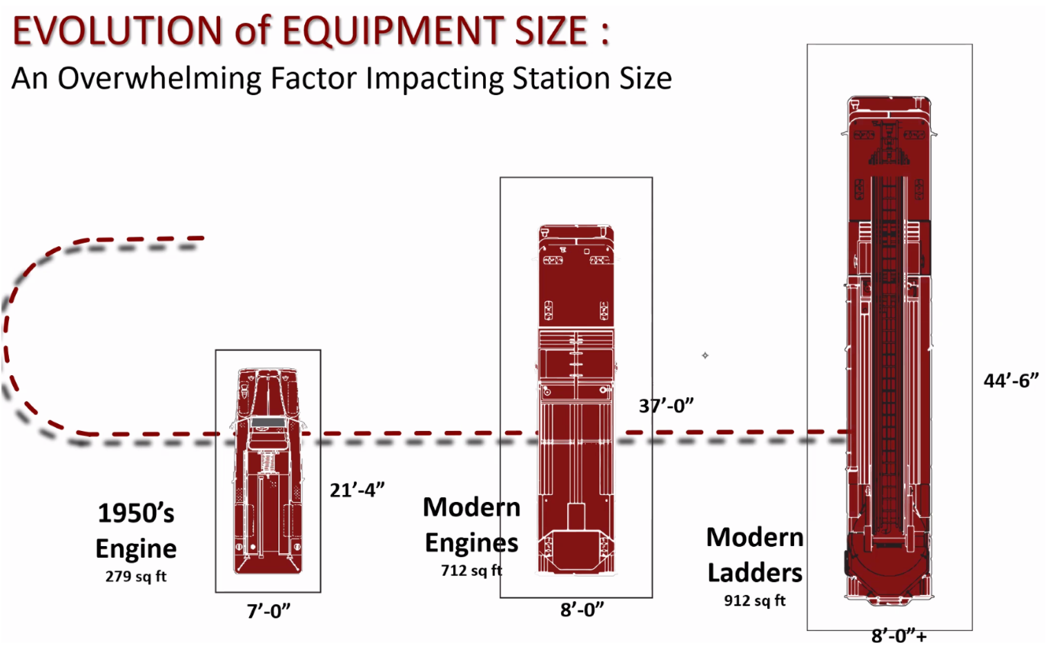
SAMPLE OF TOWN PROPERTIES COMMITTEE TRACKING SPREADSHEET
This sample gives an idea of the scope of the spreadsheet. This is a working document and is regularly adjusted as projects are completed, information is received or amended, and new projects are added as they arise.
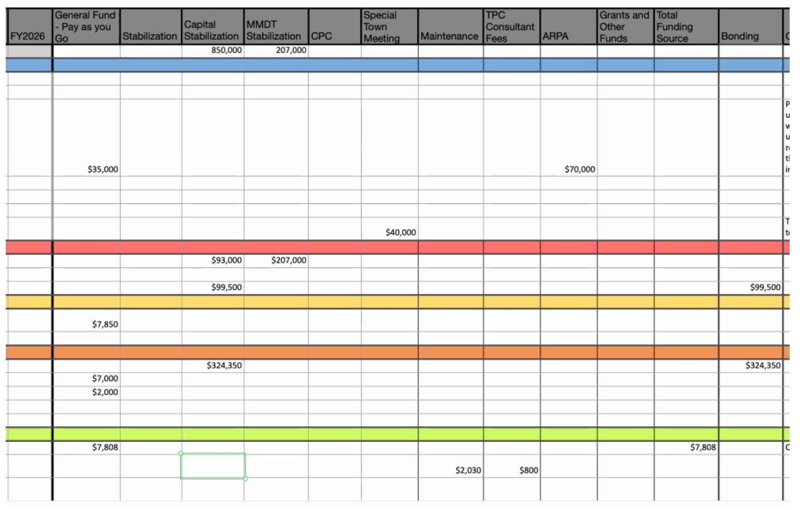
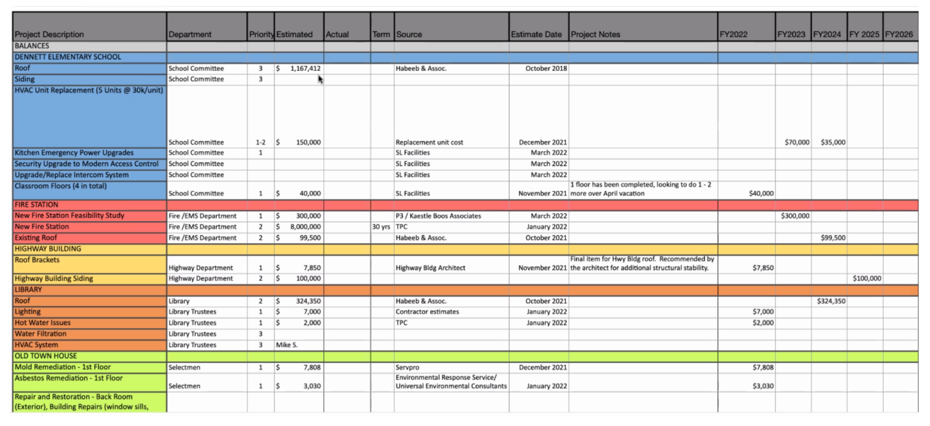

POTENTIAL TOWN MEETING WARRANT ARTICLES
A working document, not created by the Town Properties Committee
