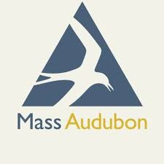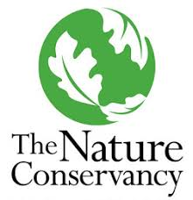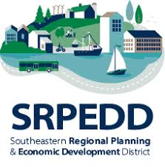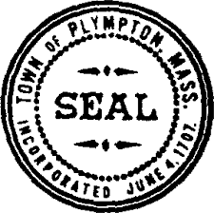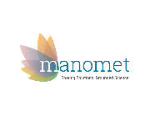

THE PLYMPTON WINNETUXET MVP PROJECT PUBLIC PRESENTATION SERIES
March 18, 2021, 6:30 PM

Conservation and Restoration Options for Retiring Cranberry Farmland

Project Overview: Plympton, MA is partnering with Southeastern Regional Planning and Economic Development District (SRPEDD), Manomet, Inc., Mass Audubon, and The Nature Conservancy to identify nature-based approaches to climate change resiliency. A series of public workshops will be held to spark local discussion of opportunities and implementation strategies.

Description: Cranberry farming has been part of the southeastern Massachusetts landscape for over 100 years. Culturally iconic and economically important, the industry now faces declining prices, out-of-state competition, and other challenges. The result is a new wave of retirements, farmland abandonment, and significant development pressure. Meanwhile, abandoned cranberry farms lose wetland characteristics as a result of legacy agricultural practices (e.g. fill, ditches, and dams). These factors represent a ‘perfect storm’ in terms of opportunity for wetland restoration, but also risks associated with alternative land-use outcomes and permanent wetland losses. This presentation will feature Alex Hackman, a Restoration Ecologist for the Massachusetts Department of Fish and Game’s Division of Ecological Restoration (DER), and manager of a program dedicated to restoring wetlands on retired cranberry farmland. Alex will describe state and federal programs that help local partners and landowners consider options to transition unproductive cranberry farmland into protected open space with restored wetlands and streams.
Alex holds an MS degree from the University of Vermont in Aquatic Ecology and Watershed Science. For the past 14 years, he has managed aquatic habitat restoration projects including dam removals, culvert replacements, stream channel and floodplain re-construction, and wetlands. Alex is a Certified Ecological Restoration Practitioner (CERP) from the Society for Ecological Restoration (SER), sits on the SER-New England Board of Directors, and won the chapter’s 2019 award for excellence in restoration. He is a founding member of Living Observatory (www.livingobservatory.com) - an organization that links science, practice, and learning about restored wetlands on retired cranberry farmland.
This project is made possible by a grant from the Taunton River Stewardship Council (Wild & Scenic Taunton River), and a Massachusetts Executive Office of Energy and Environmental Affairs, Municipal Vulnerability Preparedness Program (MVP) Action Grant.

