PLYMPTON TOWN PROPERTIES COMMITTEE
Minutes, January 25, 2024, 2023, 6:30 PM in the Dillon Training Room

MEMBERS PRESENT: Nancy Butler, Ross MacPherson, Colleen Thompson, John Traynor, Mark Wallis,
Jon Wilhelmsen (Chair)
GUESTS PRESENT: Police Chief Matt Ahl
NOTES:
- Participants are referred to by their initials. LD refers to Town Administrator Liz Dennehy.
- When possible, action items will be noted in BOLDED letters.
- “We” may refer to this committee, but it may also refer more broadly to the Town as a whole.

JW opened the meeting at 6:38.

- UPDATE/BUILDING NEEDS
- Library - RM reviewed the current HVAC system. See pages 4 & 5 for his report. Before we make any decisions about the heating system, we should engage an engineer to do the load calculations for the building. NB asked how urgent the heating issue is. RM said that for now, the one boiler and one working heat pump is keeping the building comfortable. The heat pump that is not working properly should be fixed asap and may still be under warranty. We should act now to determine the building’s needs through the load calculations, which would allow us to get a new quote for just one properly sized boiler. This quote would then be used to put a place holder on the TM warrant. Green Community grants would not help with this traditional (fossil fuel) boiler but could possibly be utilized on the heat pump/air conditioning phase of the system. JW will speak with LD to determine what funding may be available and to decide what the next step should be.
- Police Station – The most pressing need for the police station is to meet accreditation standards. Is accreditation necessary for the police? No, it does not hamper the ability of Plympton to have an active police force. Accreditation is the pinnacle of police standards. It is a self-initiated process that helps ensure professional operations, accountability, transparency, and confidence. It opens the possibility for more grants and may improve a department’s insurability status. The two things that could hamper accreditation are the sally port and the lack of secure exterior evidence storage. RM asked about the timing of the accreditation process. MA said that he would like to be ready for the weeklong accreditation inspection in the summer of 2024. They are about 70% through their prep for this.
1) Sally Port – The sally port is currently being used for overflow storage – tools, street signs, motorcycle, etc. For the safety of police officers and prisoners, and to meet accreditation standards, the sally port must be empty of all extraneous items. The original plans for the sally port included partitioning off the rear section with floor to ceiling secured fencing and adding a mezzanine area for additional storage.
2) Secure Exterior Storage – The PPD needs exterior storage for large evidence, such as cars that have been in an accident and await forensic review, or large stolen items that have been recovered. We are the only department in the area without this space. We currently borrow space from our neighboring towns but that is not the best way for us to function. This space must be securely fenced, lighted and equipped with monitoring cameras. The TPC is aware of the ongoing need for secure storage for several of the town’s departments. TM previously appropriated $12k for this PPD purpose, but a plan is yet to be developed.
3) Other PPD station issues – The previous problems with the HVAC system have been alleviated by implementing RM’s suggestions. The lack of a water treatment system will be alleviated by the installation of the new town complex wells and treatment facility.
Additional Discussion – We need to move forward with the sally port storage area soon using local (not county) ARPA funds. When we have the diagram of the fire station, we should be able to find a permanent location for a storage building and/or an exterior storage space. We want to make sure that we locate it so that it doesn’t have to be moved when the fire station is built. Though we originally thought of one large storage building for all town departments, we may want to do two instead. One would be for fire/police/other storage (such as the COA van) located on the town complex. The second would be at the town barn for the highway department. MA will determine if there is a required size for the exterior space. He will also obtain three estimates: (1) the secure storage area in the sally port; (2) the secure storage area plus a mezzanine; and (3) fencing, etc. for the secure exterior storage area if located next to the police station.

- TPC FAQS – JW reviewed some of the frequently asked questions and answers. TPC members gave additional input. This is an ongoing project.

- MINUTES FOR APPROVAL – NB moved that the minutes for 1-18-24 be approved as written. MW seconded. All aye.
- THE NEXT MEETING - February 1, 2024. Highway Supervisor Rob Firlotte will be our guest presenter. We may need to schedule the meeting with the Recreation Committee on a day other than Thursday.

NOTE: NO OTHER AGENDA ITEMS WERE DISCUSSED.

The meeting adjourned at 8:01

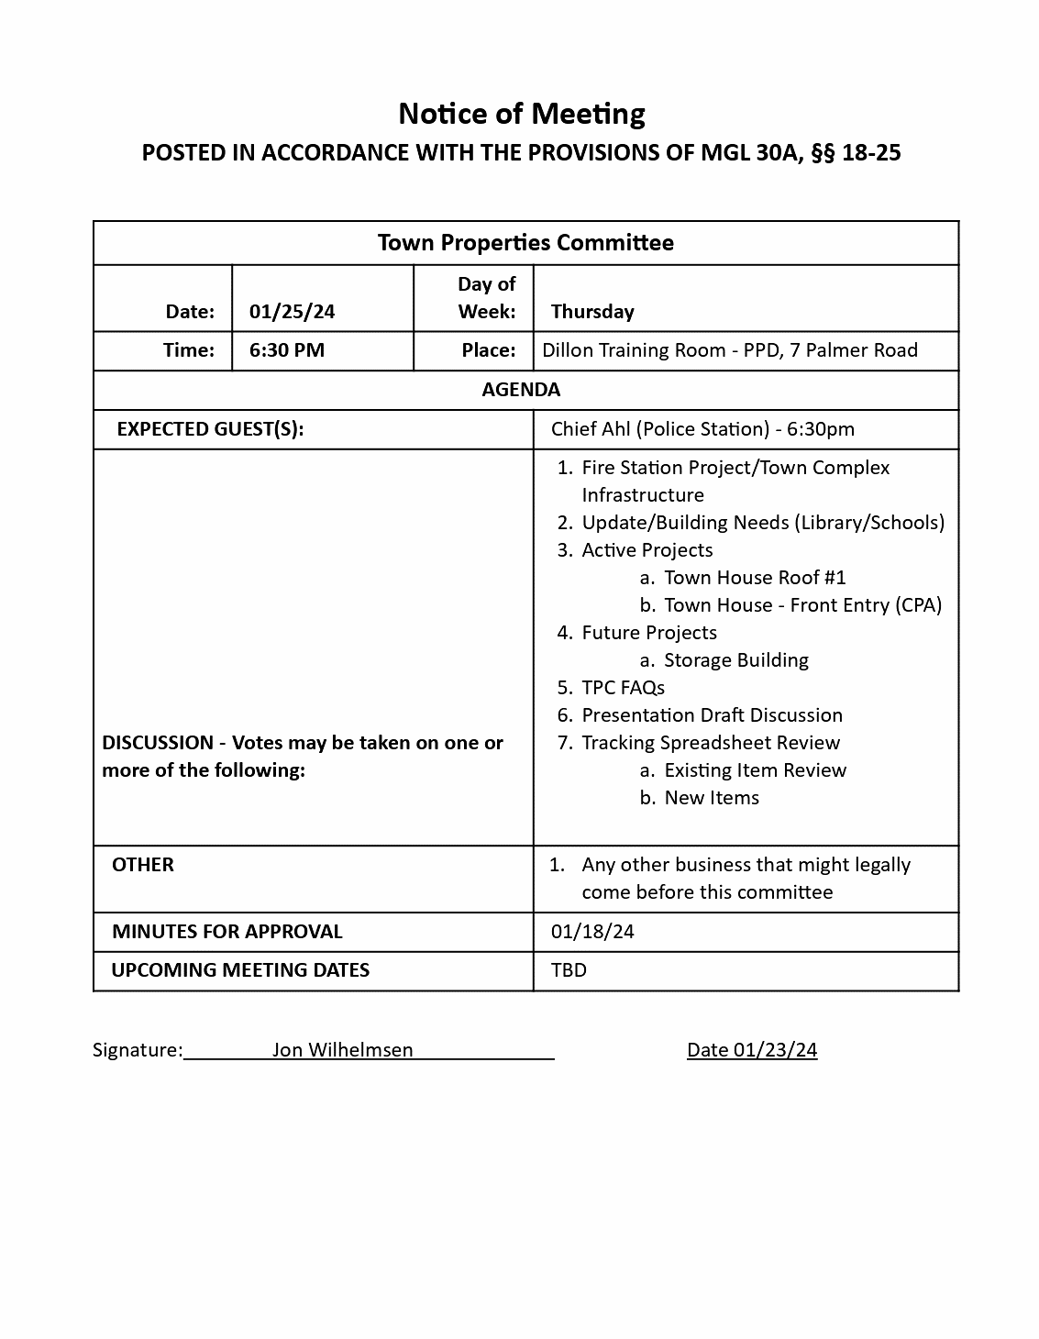
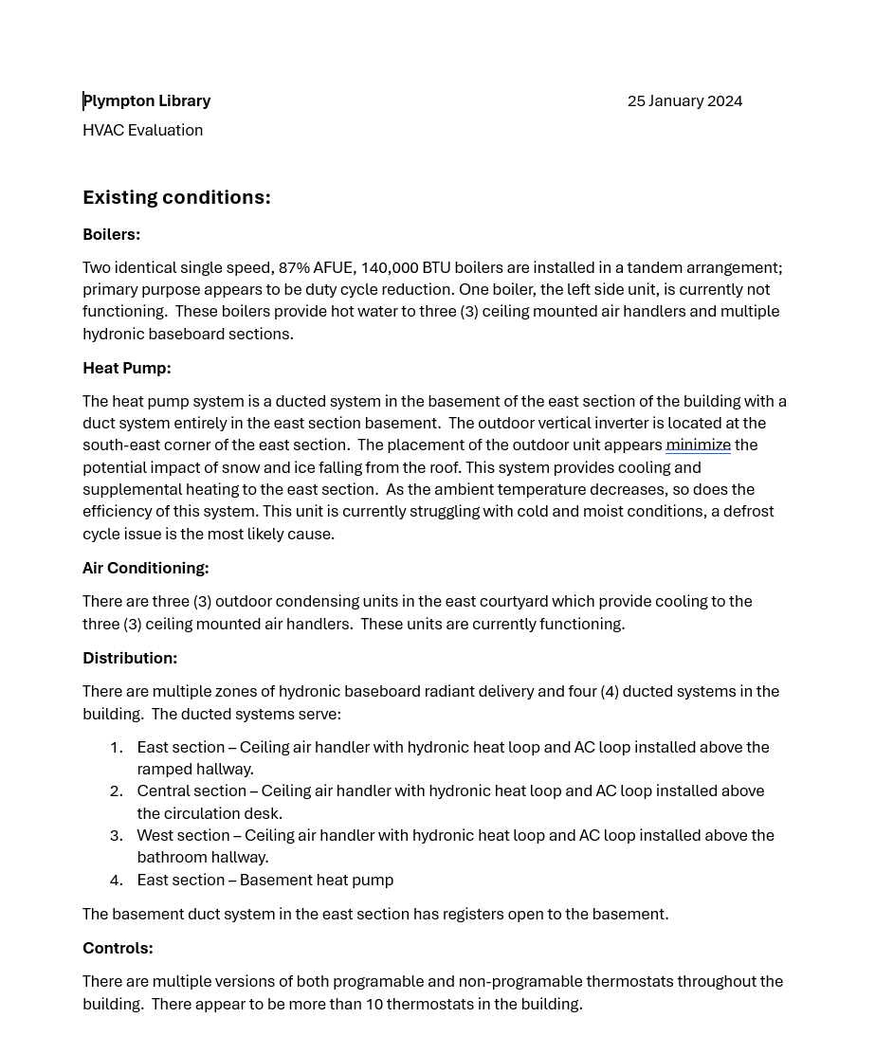
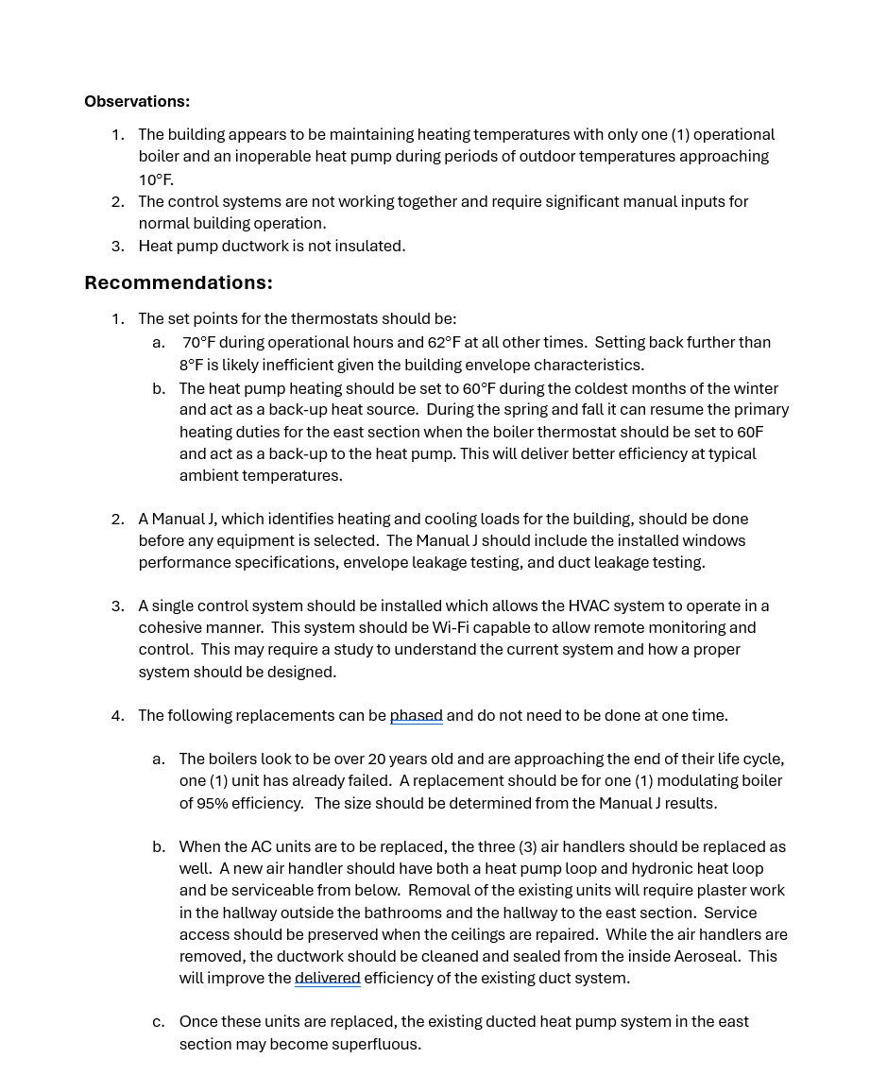
Library – Current HVAC System Report by Ross Macpherson
Library – Current HVAC System Report by Ross Macpherson, Page 2

