PLYMPTON TOWN PROPERTIES COMMITTEE
Minutes Wednesday, August 18, 2021, 6:00 PM*

MEMBERS PRESENT: Nancy Butler, Ross MacPherson, Colleen Thompson, John Traynor,
Jon Wilhelmsen (Chair). MEMBERS ABSENT: 0
GUESTS PRESENT: Selectpersons Christine Joy and Mark Russo, Fire Chief Stephen Silva, Town Administrator Liz Dennehy, Town Treasurer/Collector Christine Kelly, Town Accountant Lisa Hart, Financial Committee members Marilyn Browne, Mike Lemeiux, Steve Lewis, Nathaniel Sides

NOTES:
- This meeting was conducted on a Zoom meeting platform with members and guests participating remotely. Members and guest will be referred to by their initials in the minutes.
- When possible, documents and plans viewed during this meeting, and/or electronic links thereof, are included at the end of these minutes.
- ACTION ITEMS: In bold print
*These minutes will serve both this committee and the Board of Selectmen.

- OPENING – JW opened the meeting at 6:02 p.m. by reading the Governor’s orders of 3/12 & 15/20 which allow this Zoom meeting as a temporary change to Open Meeting Law during the COVID-19 shut-down. The meeting will be recorded to provide public access.

BOARD OF SELECTMEN OPENING – CJ called the BOS to order at 6:03 and stipulated that the conditions regarding the use of Zoom presented by JW applied to the BOS meeting.

FINANCE COMMITTEE – FinCom Chair Nathaniel Sides noted that the FinCom would not be deliberating or voting and were attending for informational purposes only
- MINUTES: JT moved that the minutes for July 28th be accepted as written. RM seconded. Roll call vote: JT aye, JW aye, RM aye, CT aye. NB abstained since she was not present on 7/28.

PRESENTATION OF CAMPUS PLAN AND PROPOSED FIRE STATION – JW began the presentation by screen sharing the final draft of the Town Campus Plan. He also mentioned the TPC’s long-range hopes for Harry Jason Park.
SL questioned the public safety driveway. JW explained that there is already an issue with visibility at that egress. This entrance was a bonus in the police station project. It will need to be reconfigured and likely a public safety activated stop light will be installed.

FIRE STATION – JW presented the PowerPoint deck for the fire station project. FCSS spoke to the need for OSHA compliance. JW spoke about the expected cost for the project – close to $6+ million.

JT spoke about Town finances. JT had met with the Town financial officers, including the Assistant Assessor. He has prepared a document that shows the Town’s financial picture as of today’s date. He expressed the need for the next step, the feasibility study to be requested at a Special Town Meeting (STM) this fall, to be done in order to get good numbers for the project.

LH said that we would not be able to expend the capital fund monies for other needed goods and projects if we use it all for the fire and police stations. JT said that is true, but the capital fund is not the only source for funding for major projects. Some things are funded through the Cherry Sheets. He affirmed again that this is why we need to move forward with the feasibility study to determine how much a fire station would cost if we do it now or wait five or ten years. The amount requested for the study would be approximately $290k, based on estimates received in May 2021. That amount may need adjusting to current market price.
MB asked why the financial report shows the public safety vehicle debt going away and suggested that we would likely need new vehicles. LD explained that the current fire vehicles were purchased through a package lease. One has been paid off and subsequently sold. The other two will be paid off as described on the report. JT gave further explanation of the report. FCSS said that Engine #1 has been rebuilt and that Engine #2 is old but in good condition. There should be no need for replacement vehicles in the near future. Additionally, the PFD has been very successful at finding grant monies to acquire vehicles. The new brush truck was 95% funded through a grant. NS concurred with that but said that there will likely need to be new police vehicles and other items to spend capital money on.

JT said that when the Town worked with the Collins Financial Group, we were told that it is best practice to keep the municipal debt at a constant amount. JW said that this is why we need help to determine the feasibility of the fire station project. There are other expenditures coming along, such as the Dennett School roof, but there will also be alternate funding available for much of that. The State will pay a major portion of the roof, but we will be responsible for some of it. The important things is to get a plan in place to figure out our proposed/known expenses and then determine how to fund them. FCSS agreed and said that something needs to be done for the fire station. We need an objective third party to review, price, and plan the project – soil tests, building needs, placement, infrastructure, etc. – to help us determine the best course forward.

JW said that all but one member of this committee also served on the Public Safety Building Committee which worked to provide a new police station for the Town. When doing that work, we quickly realized that we needed professional help to find out the costs, determine placement, get initial designs, and trim those to make them Plympton appropriate while still meeting the departmental needs and government stipulated requirements for the station. We are now looking for support to do the same work for the proposed fire station. We would like to have a feasibility study funded at a STM in October so that we can produce a well-prepared plan to be ready for funding when it becomes available.
CJ asked if the assessors confirmed the monies coming in from Sysco. JT said that they had and had even indicated that they expected the amount to be a bit higher than shown on the financial report. NS is concerned that Sysco may not be in Plympton in 20 years thus the source for the capital fund would dry up. JT said that some business will be using those buildings and paying the Town. He had met with the head of Sysco who confirmed that this is their main facility and the largest on the east coast. FCSS pointed to all of the commercial development that is happening in our surrounding towns. Major projects are proceeding in Carver, Middleboro, and Kingston. The south shore is the fastest growing area in the state and New England is the fastest growing area in the country. JT confirmed that we are only looking for funding for the feasibility study. The Town finances will be reviewed and researched again.

CJ asked about the funding source of the $290k feasibility study. JT said that because of the restrictions on STM appropriations, the funding would need to come from the regular stabilization account. A transfer would be made from the capital stabilization account back to the stabilization account at the 2022 TM.

NS asked if there would be other articles on the STM warrant. LD said yes, but none requiring funding. There are solar agreements and Town Counsel has recommended some bylaw changes to clean up the organization of the BOS.

MB asked if we have people in mind to do the feasibility study. FCSS said that he knows of two companies that will give an honest third-party opinion. JW said that based on our previous public safety building contract with P3, we would likely get their help to write the RFP for and locate an appropriate feasibility consultant.

MB asked how long the study would take. FCSS estimates that it would take around six months. Our study is relatively simple and does not require the acquisition of land. JW said that we should be able to be done with the study to take the next step at the May 2022 TM. Before the next step is taken, the TPC want to make sure that we (TPC, BOS, FinCom, financial officers) are all on the same page for the project and that the timing is right. Our goal is to have the information ready for the next step but not to rush to that step unadvisedly.

CJ said that she would rather see the feasibility study on the TM warrant and wonders why we want to put it to a STM. JW said that we are very concerned about price increases. RM said that there are many infrastructure projects being funded now. We need to find a contractor that needs this bid to further their business. This is what we were able to do with the police station. The contractor needed our police station project to move his company into a larger field of bids. If we can’t find this sort of contractor, the prices (particularly labor) will take likely us out of the market.

LD said that the TPC has been taking a long-term, large-scale view of the Town campus and other properties. Having the engineering/design work done soon will help sort out other Town campus issues like the septic and water systems. We will be able to tap American Rescue Plan Act (ARPA) money and matching county funds, but only if we have a design in place and be shovel ready as soon as possible.

JW said that we know we will need a new septic system and well for the new fire station and this will benefit the campus as a whole. Whether we build the fire station or not, getting that infrastructure work done will help the systems in the other campus buildings. It will likely be possible to tie into the new system to relieve the stress on the old.

MB asked whether there are issues with contractor materials availability and price increases. LD said yes but that it is fluctuating now. It is helpful to get prices locked in, as we learned with the Town barn roof project. RM agreed that prices are coming down again. One problem is that some of the manufacturers reduced their production on the expectation of a slowdown. Now there is an infrastructure and construction boom, and manufacturing is picking up again. Labor costs and availability are still an issue.

CJ asked what the TPC needs from the BOS tonight. JW said that we need the support of the BOS and the FinCom for the feasibility study. LD said that the BOS needs to decide about holding a STM, which will also be needed for other items as previously discussed, so that we can deal with the COVID constraints on the meeting set-up. Things will be done as they were for the TM, but it takes time to put this in place.

CJ asked MR if he would like to comment. MR said that the fire station project has been at least ten years in the making. We know that sooner or later we will need to do something with the fire station. We must know what we need to do and how to move forward, so we need the study. We will not be gaining anything by waiting since costs will just be worse in five years. It looks like this can be done as the police station was done, without affecting the tax rates.

RM said that a lot of people wonder why we just don’t rehab the current station. Rehab always costs more than you think it will and may not provide a long-term solution. Additionally, we would have to spend a great deal of money (maybe as much as $1.5 million) to create temporary quarters for the department while the rehab was progressing. It would be less fiscally responsible to spend the funds on rehab and temporary housing than to just build a new station that will meet the Town’s needs for many years to come.

CJ asked if MR is okay with holding a STM in the fall. MR said yes. He still has hopes that there will be more infrastructure funds available from state or federal sources and we need to be shovel ready to take advantage of every source. CJ asked if JT agrees. JT said yes.

Christine Joy made a motion that the Board of Selectmen approve holding a STM and support the Town Properties Committee warrant article for a fire station feasibility study. John Traynor seconded the motion. Roll call vote: Mark Russo aye, John Traynor aye, Christine Joy aye.

MR asked when the STM is expected to be held. LD said mid-October or so.

7:16 CJ left the meeting, confirming that MR would adjourn the BOS meeting. Other guests, except for LD and MR, left the meeting at this time.

At 7:19 MR moved to adjourn the BOS meeting. JT seconded. Roll call vote: Mark Russo aye, John Traynor aye. MR left the meeting.

THE TOWN PROPERTY COMMITTEE MEETING CONTINUED WITH AGENDA ITEMS:

HARRY JASON PARK (HJP) – PAYS and the Recreation Committee will meet with us on August 25. JW will follow up with the RecCom so that they can post their meeting. Our hope is to eventually create a recreation/sports plan similar to our town campus plan. This will again require professional help. RM confirmed some of PAYS needs/wants outlined in our last meeting. We will want them to elaborate on this and suggest phasing so that their program needs are met and expanded. JW and RM provided some notional drawings for HJP. HJP will also require electricity and water to meet long-range plans.

NB asked about walking trails. RM said that there is plenty of room at HJP and he would also like to bring the Scouts into the conversation. JT said that there are 68 acres in HJP with approximately 30 of that fully dry and usable. There is also some town-owned land across the street from HJP.

RM said that we could easily change the baseline length on the softball field at the Dennett so that it could temporarily accommodate the baseball games. This would take relatively short money. JW reminded us that this is going to be a long-term project. It isn’t going to all happen within a couple of years, but we need to plan it all out.

CT asked about including some possible adult use – tennis courts, dog park, etc. There was general agreement. RM reminded us that with moving the basketball court to the campus, the current b-ball space would likely make a good dog park.

ADA RAMP – This project is about ready to go out to bid. Pricing should be better now than it would have been in June.

FLAG POLES – There has been a delay because of the weather and some equipment issues. JW asked if there is a way to add solar lighting to the pole so that the flag can remain properly in place 24/7. It is sometimes an issue to get it raised and lowered properly every day. LD will follow-up on the scheduling of the work and will pursue information about the lighting.

TOWN HOUSE ROOF – JW and RM spent an hour with roof assessor Scott Bancroft looking at the building, particularly the venting and insulation issues. They asked the Scott to figure out what needs to be done and how to phase the work so that the roof leaks and ice dam issues can be fixed properly. There will likely be alternate bid options created so that we will be prepared to go back to TM to appropriate funds for the next phase.

DENNETT SOLAR – still working on it. JW will get back to us when there is something to report.

- NEXT MEETINGS: 8/25/21, 6pm to focus on HJP.
- ADJOURNMENT: 7:45

REDUCED VIEW OF DOCUMENTS USED DURING THIS MEETING. ELECTRONIC LINKS ARE PROVIDED WHEN POSSIBLE.
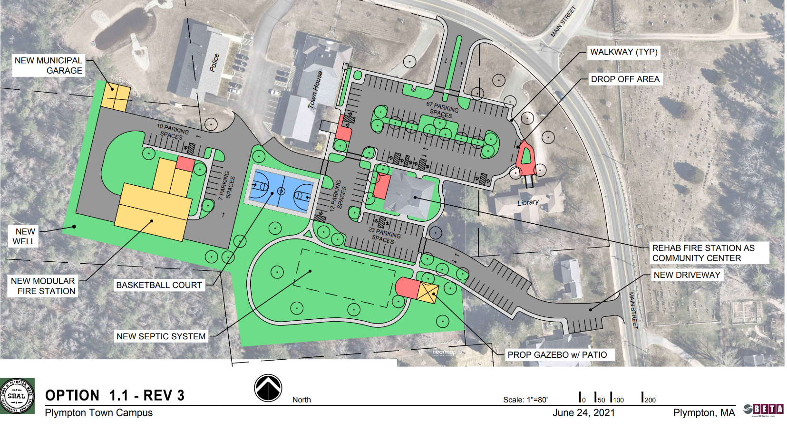
Town Campus Plan - Final Draft - 1.1 REV-3 (1).pdf

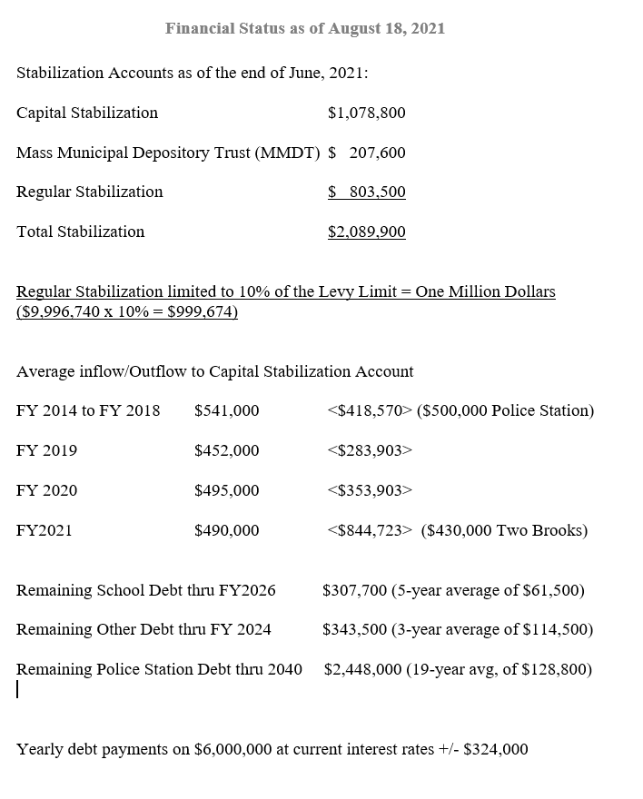
Financial Status as of August 18, 2021
Plympton - Financial Status as of August 18^J 2021
TPC - New FIre Station 8_18_2021 POWERPOINT.pdf
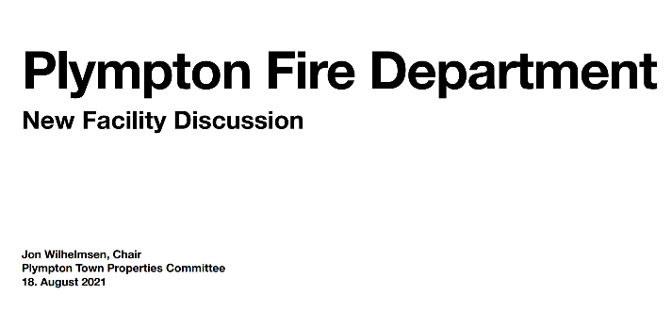

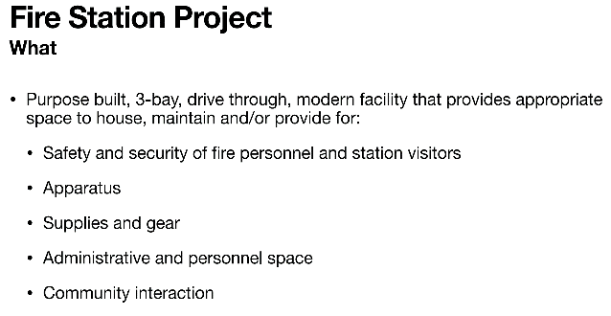
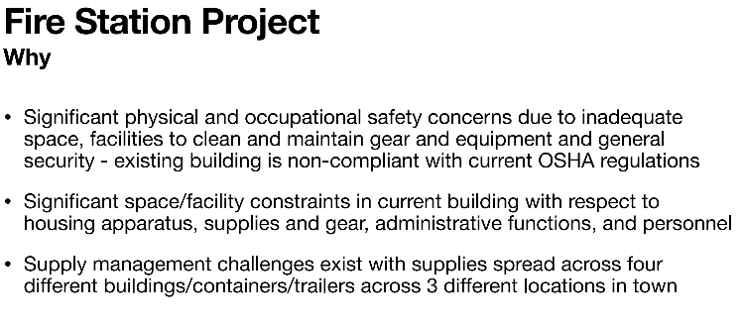
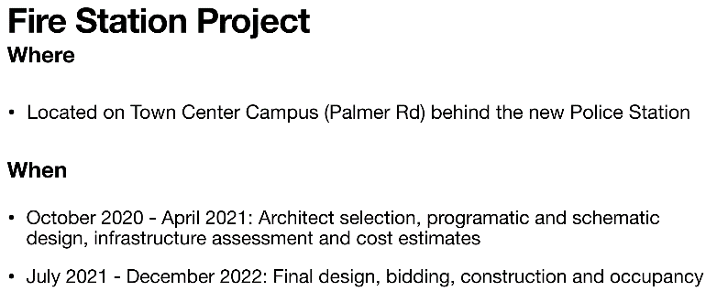
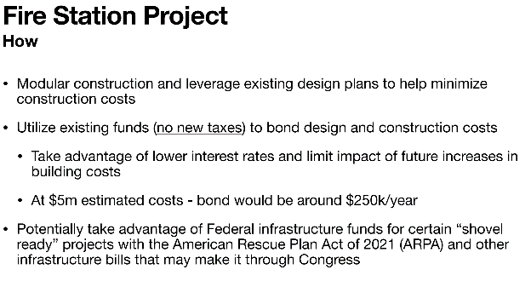

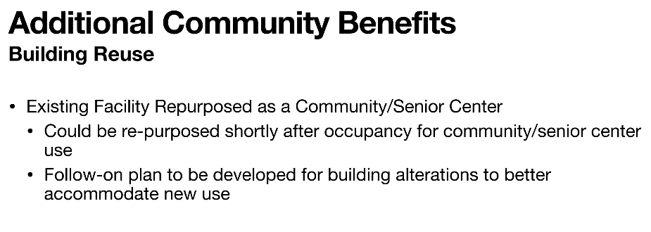
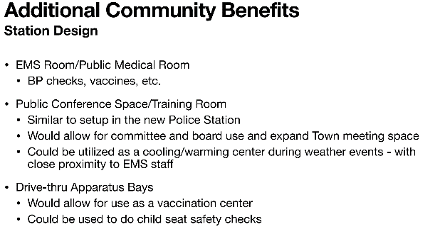

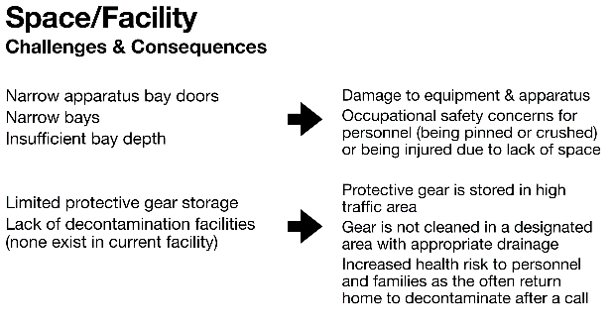
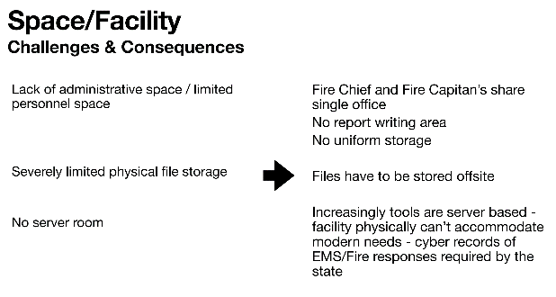

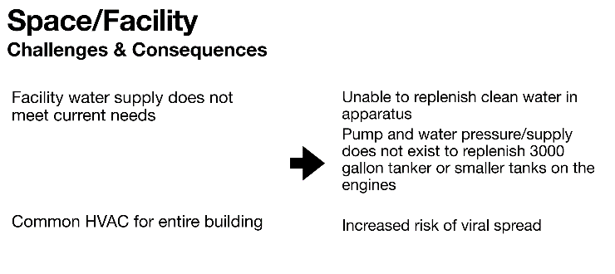
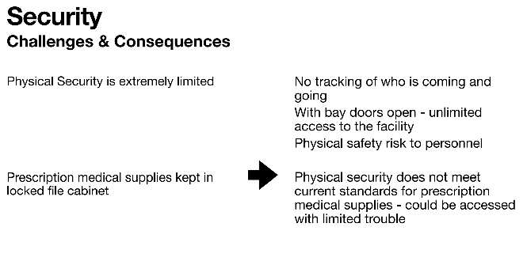
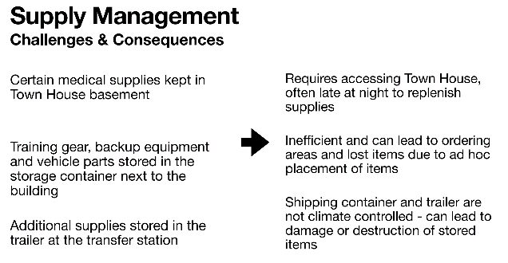

Harry Jason Park Possible Clearing (1) for Fields.pdf
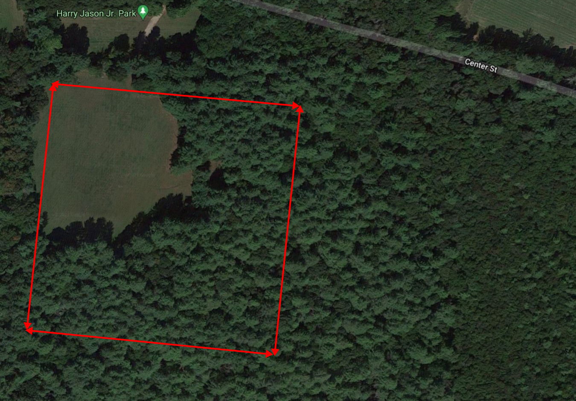

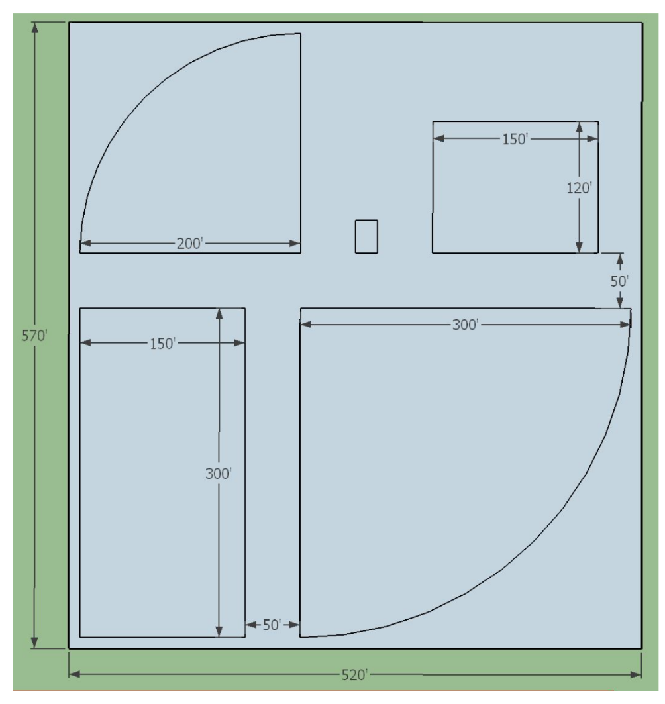
Harry Jason Park - Possible lay-out of sport fields in cleared space

