PLYMPTON TOWN PROPERTIES COMMITTEE
Minutes, March 8, 2023, 6:30 PM

MEMBERS PRESENT: Ross MacPherson, Colleen Thompson, John Traynor,
Jon Wilhelmsen (Chair). ABSENT: Nancy Butler
GUESTS PRESENT: Recreation Committee (RC) reps Angelo Boccalini, Mark Reilly (also on PAYS)
NOTES:
- Committee members and guests will be referred to by their initials in these minutes. LD refers to Town Administrator Liz Dennehy.
- When possible, action items will be noted in BOLDED CAPITAL letters.
- “We” may refer to this committee, but it may also refer more broadly to the Town as a whole.
- This meeting was held in-person in the Dillon Training Room of the Plympton Police Station.

JW opened the meeting at 6:36 by introducing the RC members.

- PLYMPTON RECREATION COMMITTEE – The RC provided a prioritized list of concerns and wishes for the town’s recreational and athletic needs (see pages 5 & 6). MR noted that there is an earmark from the state that Kathy LaNatra’s office was able to obtain for recreation maintenance and improvements totaling $25K. LD will work to establish a RC Gift Account so that these funds can be available to use for field maintenance and rec. improvements. JW confirmed that the field advertising signs are under the purview of the RC. MR/AB said that the RC had authorized PAYS to work on selling the advertising space on the signs.

Of particular concern is the state of the Dennett fields, the state of the Holt fields, the Holt small field back stop fence and Holt field dugout roofs. They don’t want to fix things just for the season if a long-term solution can be completed. RC has told PAYS to stay off the Dennett fields until the new grass is established but there isn’t much time before the season begins. They made irrigation system improvements last year to support the grass growth, but by the end of the year the field was just mud. They had hoped to use the Harry Jason fields, but that area would need work to level it even for just practice. There are hillocks and divots that could cause injury. MR asked where the RC should be spending their money now. There are two soccer practices per day at the Dennett and then four games on each weekend day.

JW described our initial thoughts for Harry Jason as a sports complex. It is a good plan for the future. The challenge is that there are many other projects competing for the same funds.
He also explained the septic and water issues facing the center complex. Some of those issues are going to be solved by using the land in the Holt fields without threatening their primary use. This work will be done off season, so it won’t disrupt the baseball season. Additionally, the fields could be stressed by the installation of the new system(s) and therefore will be repaired and reseeded as needed. It is hoped that they will be left in much better condition and any systems installed would be done so as not to inhibit the use of the fields once they are in place.

MR said that it is difficult to get estimates for the fences, and the dugout roofs. Companies don’t respond. They did get one estimate for $3k to fix the fencing, but $5k would re-orient the field and move the fencing away from the recurring problem of frost heaves. JW said that we will have a better understanding of the well and septic plans in 5-6 weeks.

RM asked what the ideal location for the fields would be. MR said to leave the larger field placed as is but reorient the small field so that home plate is at the snack shack side. For the health of both fields, the trees along the cemetery side need severe trimming and clean up. JT will talk with Tree Warden Bill Hayes to put him in contact with MR.

MR said that PAYS would be looking for answers about the dugouts and fencing at tomorrow night’s meeting. JW said that he will get estimates for the two roofs with the shed roof as an alternate/add on. JW thinks that the roofs may be able to come out of maintenance funds.

Regarding the fencing, do we want to do an warrant article this year? Can we get through this year with the fields as they are with the clear understanding that the money will be in place to do the full job, post septic/well project. There are other options besides the regular chain link that’s currently in use. Removable screening would last longer and would not be subject to the frost heave issue. How ever it is done, the fencing is basically a one-day project. The first thing is to reorient the field pending the septic/well plan. There’s also a need for lighting and improved electrical access both at the Holt field and the Dennett. This work should be done when the ground is torn up for other purposes. We need to group the projects so that they are done reasonably and, in the best, financially responsible way.

RM said that there are lots of good ideas for recreation and sports and many of them are tied into the town’s master plan. We just need to determine what we can afford to do and the timing for phasing in each aspect. He also thinks that all of the soccer should eventually be at the Harry Jason Park.

MR said that they also need more storage at the Dennett. They have researched the location for the new shed. It is in a blind spot and won’t interfere with the players or spectators using the fields. JW suggested creating a general article for “safety upgrades” which will allow more leeway in how the multi-purpose use of the funds. It should be worded to allow any extra monies to go into the new $25k recreation account (see first paragraph) to be used for infrastructure and field improvements as needed.

JW suggested doing an article for the May Special Town Meeting so that it is available to uses as soon as possible. Monies appropriated in the regular Town Meeting will not be usable until after June 30th. JW and JT will follow up with LD about the $25k account. PAYS needs to understand that the money for projects needs to be appropriated a year in advance. That’s just how town budgets and town meeting work.

AB asked about having the fields professionally maintained – weeds removed/killed, seeding, fertilizing, etc. JW said that this should be part of the RecCom’s regular maintenance budget.
AB also asked if the Harry Jason fields can be made usable ASAP and how that gets accomplished.

RecCom exited the meeting at 7:45

- FIRE STATION STUDY – Subsequent to our last discussion, Context was able to take about $500,000 off the current estimate (see page 7). The DEP should be out to review the location in another week or two. The Board of Health will be included in the notice distribution list.

- LIBRARY – Having trouble locating the leaching field for the septic system. The library wasn’t a town building until twelve or so years ago. The Plympton Health Agent will look at more plans to try to locate it.

- TOWN HOUSE ENTRANCE – JW distributed a Entry Concept document showing the current layout and the proposed changes (see page 9).

- MINUTES – awaiting amendment.

- NEXT MEETING – Thursday, March 23, 2023

The meeting adjourned at 8:09 pm

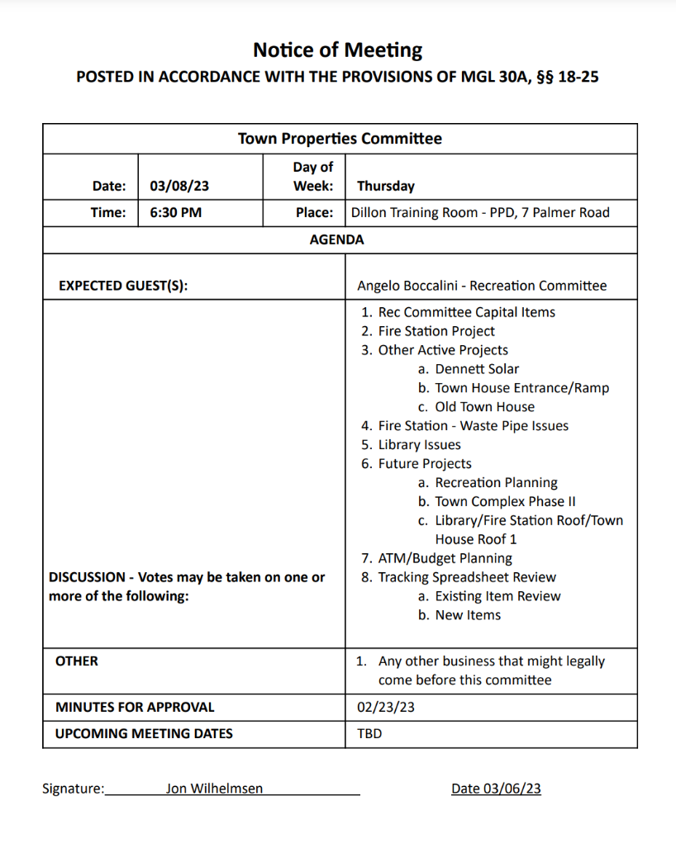
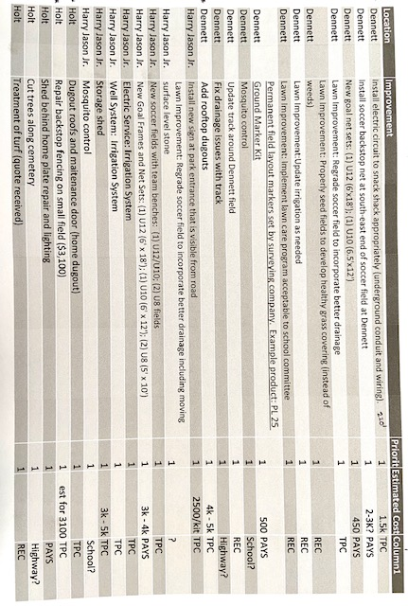

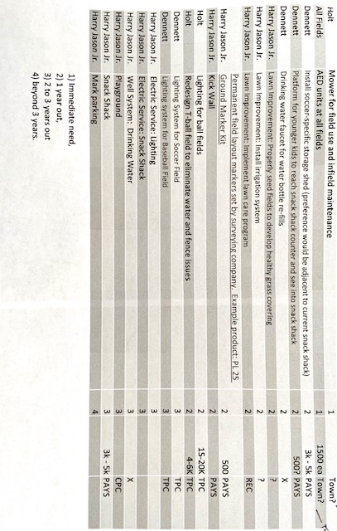
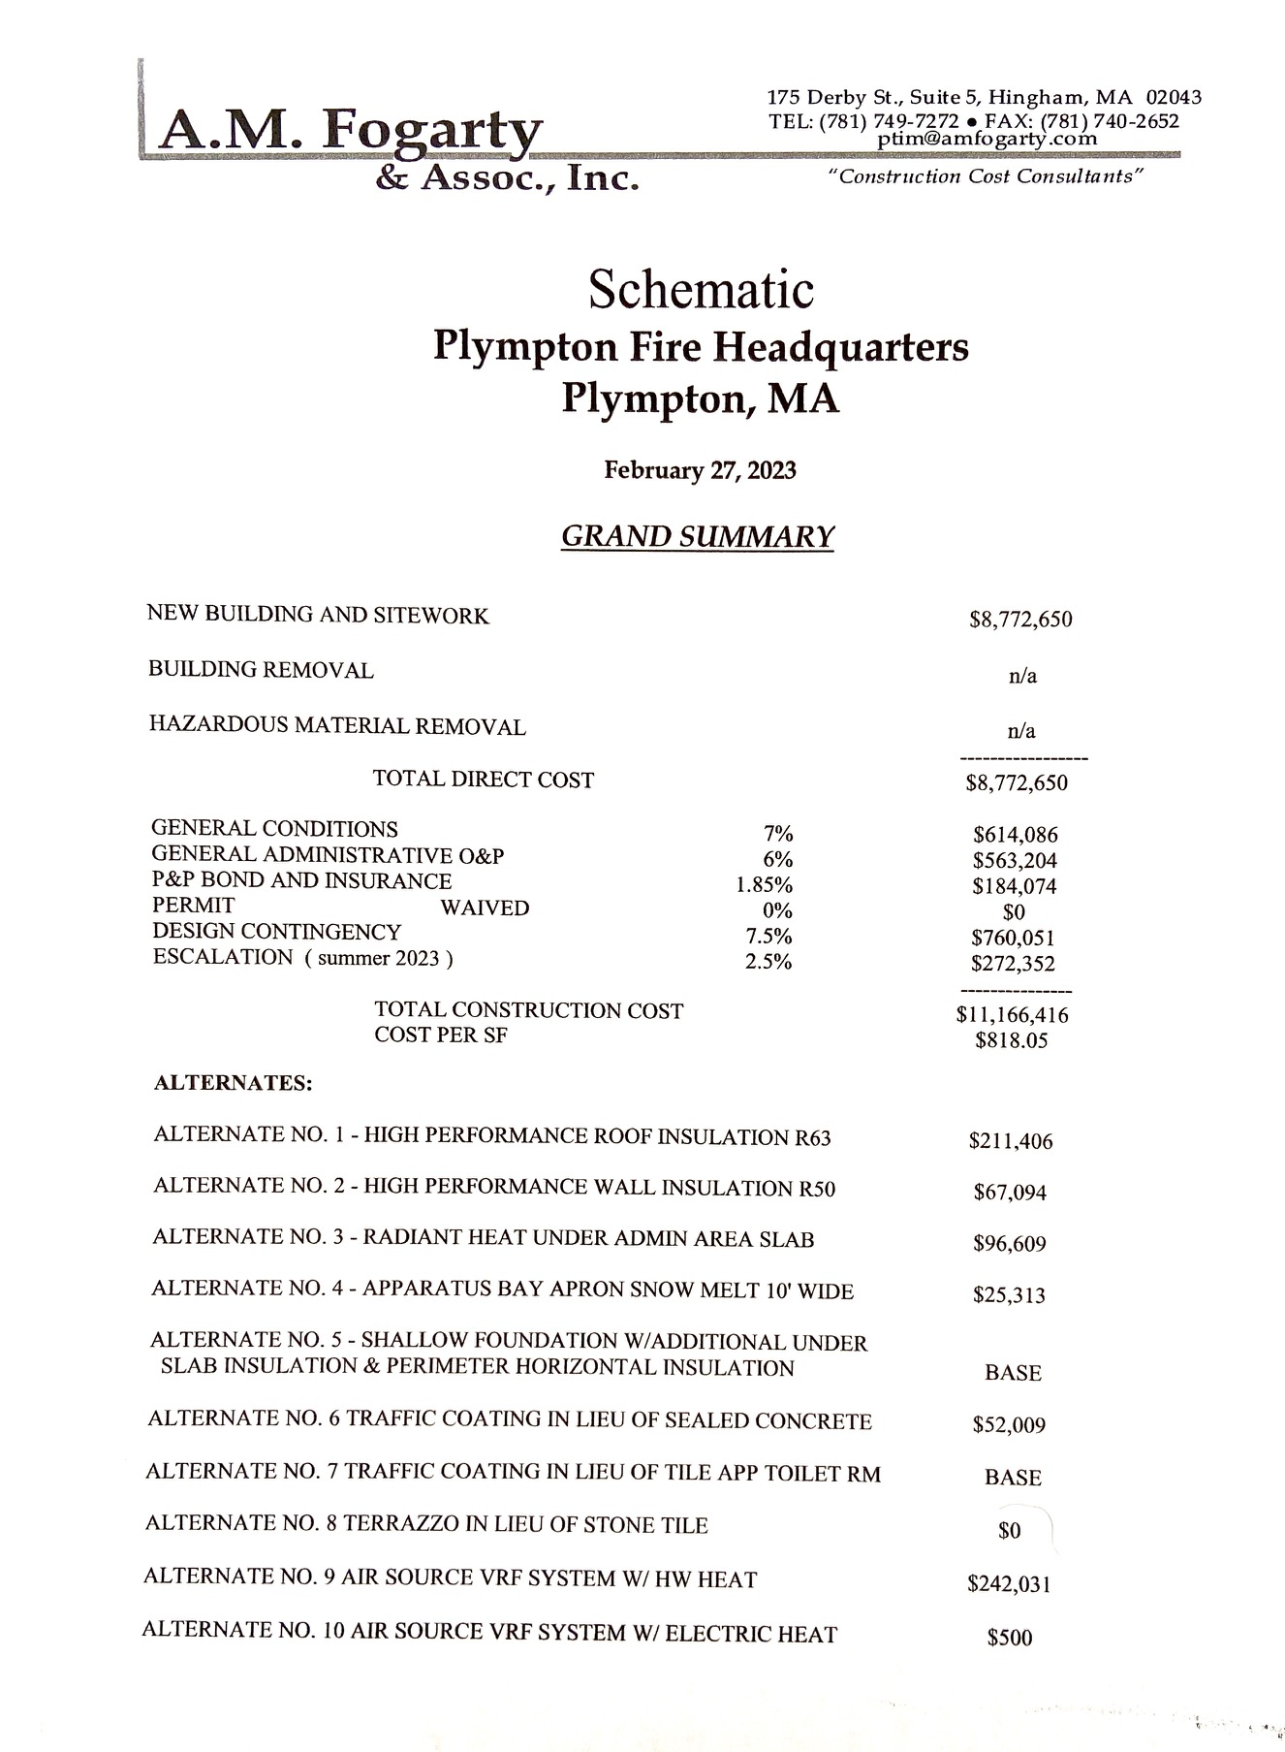
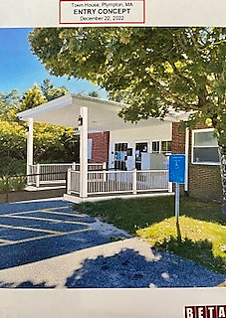

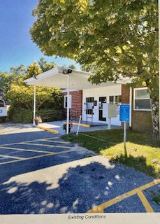
PROPOSED

EXISTING

