PLYMPTON TOWN PROPERTIES COMMITTEE
Minutes Wednesday, March 23, 2022, 6:00 PM

MEMBERS PRESENT: Nancy Butler, Ross McPherson, Colleen Thompson, John Traynor,
Jon Wilhelmsen (Chair).
- This meeting was conducted on a Zoom meeting platform with members and guests
participating remotely. Members and guests will be referred to by their initials.
- ACTION ITEMS: In bold print

OPENING – JW opened the meeting at 6:02 p.m. by reading the Governor’s orders of 3/12 & 15/20 which allow this Zoom meeting as a temporary change to Open Meeting Law during the COVID-19 shut-down. The meeting will be recorded to provide public access.

- TRACKING SPREADSHEET REVIEW – JW reviewed the updated spreadsheet (See pages 4 & 5). There will be a new plan for what will be expensed through the ARPA funds. For example, because the HVAC units for the Dennett will take a long time to acquire due to manufacturing delays, we will likely seek to do all of the units at once rather than spacing them over a number of years. This is the type of project that falls firmly within the stricter use guidelines of the county administrated funds. There is more leeway with the state funds.

- FINANCE MEETING UPDATES – JW and JT attended the recent Finance Committee (FinCom) meeting to review the PTPC Tracking Spreadsheet and potential Town Meeting articles. FinCom did not have a lot of questions. We will need to meet with FinCom again after Town Meeting to begin thinking about next year.

- REVIEW OF POTENTIAL TOWN MEETING WARRANT ARTICLES – See page 6.
CT mentioned a question she received from a resident – Will the Fire Station Feasibility Study (FSFS) include a look at refurbishing the current station as well as building new? Generally, our answer is that this has been researched, discussed, and discarded. RM noted that bringing the building up to code and adding a new bay or two will likely cost nearly as much as building a new station. RM said that we should emphasize that the fire department has been diligent in acquiring grants for equipment, including the new brush truck. These grants save the Town a great deal of money, but we need to have adequate storage/garage space to keep the equipment in good working order and in service for as long as possible.
JT said that people want to know why the study cost is $300k instead of something like $100k. JW noted that our planned study will complete much of the work needed to move the Town to be nearly ready to build. This includes nominal plans for a Plympton-appropriate building, site test work/soil sampling, and cost estimates. JW will contact Kaestle Boos to get a list of what is included in the FSFS.

We will hold some public forums to discuss this article prior to Town Meeting. This article will require a 2/3 vote since the money will be coming from the stabilization account. Our next meeting will include preparing the FSFS article presentation at Town Meeting. This is the same type of preparation we did for the police station. The Town appropriated money to do the study and prep work for the station then we went back to the voters at a subsequent TM to get the money to build the station.
- ACTIVE PROJECTS
a. Town House Roof – Out to bid.
b. Dennett Solar – Contracts with the solar attorney.
- FUTURE PROJECT – No updates except on item “b”
b. Town Campus Landscaping Plan – The Highway Department will reset the curb stops that were moved by a snowplow. JW met with town resident Mike Jardin, a landscape designer, about the landscaping of the ramp and police station areas. MJ noted that the grading around the TH is all wrong for good drainage. Although the current TH landscaping was done with good intent, it is not really good for this location. The goal for any new landscaping should be low maintenance and low mulching once the plants have become established and filled in the space.
- OWN BUILDINGS – No updates
- MINUTES – NB moved that the minutes for March 3, 2022, be approved as written JT seconded. Roll call vote: NB aye, JT aye, CT aye, JW aye, RM abstain
- NEXT MEETING – 4/6/22 at 6:30. This meeting will likely be in person in the police station community room.
- ADJOURNMENT – 6:49 p.m.

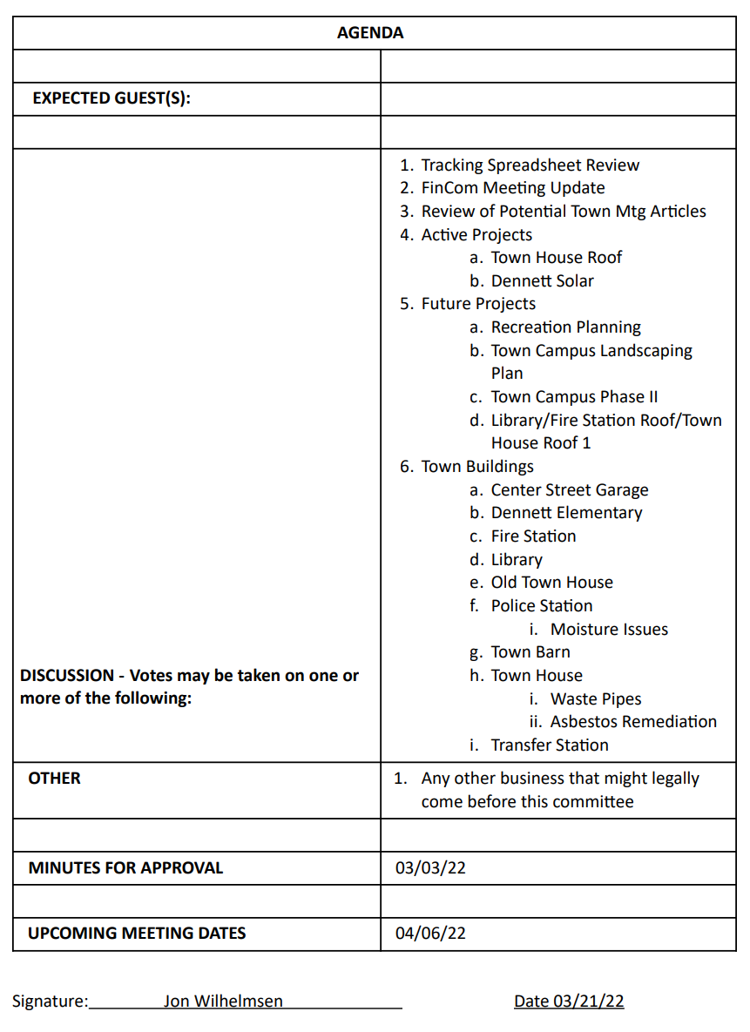
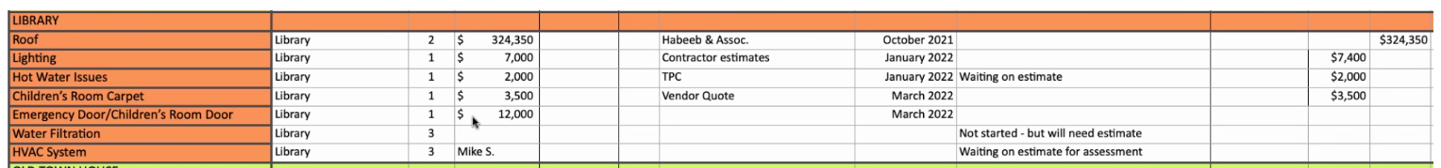
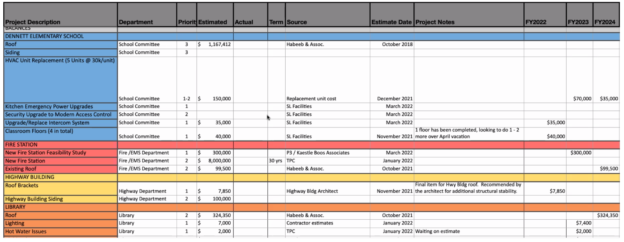

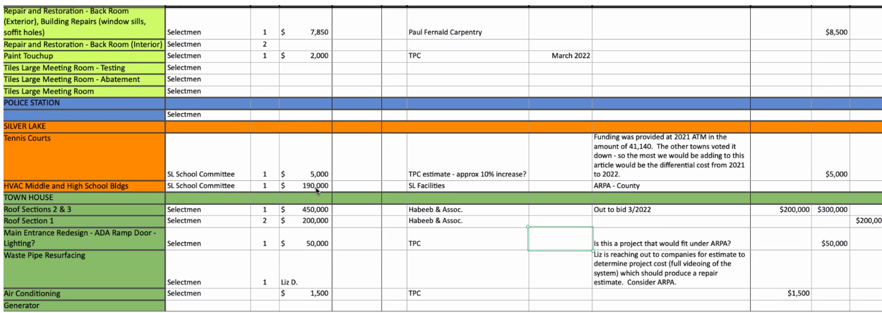
POTENTIAL TOWN MEETING ARTICLES
A working document, not created by the Town Properties Committee

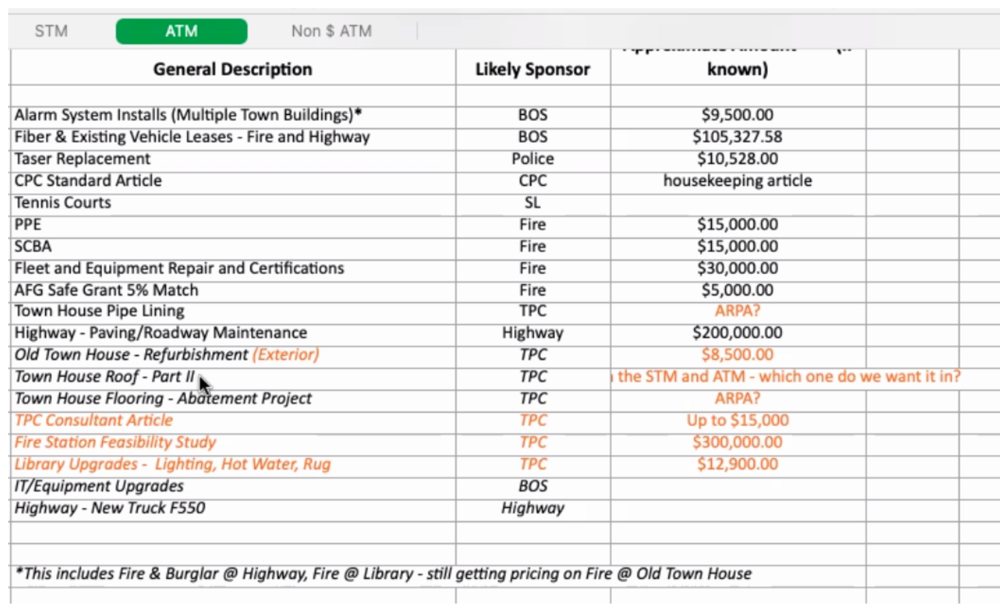
Approximate Amount if known

