PLYMPTON TOWN PROPERTIES COMMITTEE
Minutes Wednesday, August 25, 2021, 6:00 PM

MEMBERS PRESENT: Nancy Butler, Ross MacPherson, Colleen Thompson, John Traynor,
Jon Wilhelmsen (Chair). MEMBERS ABSENT: 0
GUESTS PRESENT: from Harry Jason Jr. Park Study Committee – Jackie Freitas and Robert Doucette. From Recreation Committee – Amy Hempel, Katrina Player and Erik Player. From PAYS Lillie Krueger and AH

NOTES:
- This meeting was conducted on a Zoom meeting platform with members and guests participating remotely. Members and guest will be referred to by their initials in the minutes.
- When possible, documents and plans viewed during this meeting, and/or electronic links thereof, are included at the end of these minutes.
- ACTION ITEMS: In bold print

- OPENING – JW opened the meeting at 6:02 p.m. by reading the Governor’s orders of 3/12 & 15/20 which allow this Zoom meeting as a temporary change to Open Meeting Law during the COVID-19 shut-down. The meeting will be recorded to provide public access.
JW explained that the purpose of the Plympton Town Properties Committee includes the oversight of town-owned buildings, systems, and lands. The TPC was also charged with developing a Town Center Campus Plan. This work not only includes looking at the current situation but also looking forward. Long term planning will ensure that things are done affordably, correctly, and appropriately for Plympton.
JW screen-shared the Town Center Campus Conceptual plan and described some of the reasoning that went into its development. In conjunction with this plan, we need to look at the town’s recreational and athletic needs and desires.

HARRY JASON PARK – JW shared the arial photo of HJP and the conceptual drawing of possible sport field configuration. RM described the size and purpose of the various fields. He noted that we could probably fit two soccer fields in the area that is currently cleared but that we would need to clear more to create more fields and building space.

JW said that we need to talk about this now because in a Special Town Meeting this autumn, we will be seeking funds for the next phase of the Campus. That work may lead to the removal of the current ball fields. Therefore, we need to consider where, when and how we are going to create new fields and recreational areas. We need a plan for this, and we need the input of the committees represented tonight – HJ, RC and PAYS. We know that in order to accommodate the new recreation center, HJ will need electricity, water, and at least one building on the site.

AH asked about the timeline for the new fire station. She wants to make sure that fields continue to be available. JW responded that if everything goes perfectly, we will start with the fire station after the 2020 Town Meeting. All we have right now is a conceptual plan. We need firm plans before anything can be done. We need the feasibility study to determine if we can move to that next step.

AH noted that the drawing does not include a softball field. A softball field is different from a baseball field and our plans must include one. RM noted that the softball field at the Dennett would still be in play.
JW said that we want to design the ultimate plan and decide the best way to phase it. We would probably not be able to do something every year but phase it out over three – ten years. We would likely tap Community Preservation Act (CPA) funds, maybe grants and even some fund-raising.

AH said that the HJ location is not ideal but new fields would be great to have. JW said that the end goal may be one location at HJ or it would likely continue to include the fields at the Dennett. AH said that the fields at the Dennett are in relatively good shape so it is fine to continue using them. She just wants to make sure there is a long-term plan to include all of the needed fields.

AH asked about possible traffic issues in the autumn when the Sauchuk corn maze is active. Traffic can be very bad, and the street is crowded with parked cars. RM said that he spoke with Scott Sauchuk. SS said that he plans on continuing with the reservation policy which was developed in response to COVID. This gave created consistent known business and reduced traffic and parking problems. We will have to pay attention to these things during the busy fall season.

JW said that this will be a process, not a quick fix. We will need to hire a consultant that specializes in this type of project, and we will need continued input from the committees and residents.

CT said that it would be good to have a schedule to know exactly which and when fields are in use. AH said that baseball and soccer are now three-season sports. JW said that even though basketball is an inside sport, we need to include it to give the consultant the full picture.

The RecCom and PAYS people left the meeting at 6:29. JF and RD stayed for the rest of the meeting.

FIRE STATION – General Discussion and comments about last week’s meeting – JW said that he had not yet received any feedback from FinCom. He will touch base with Nate Sides and Liz Dennehy. RM said that it is good that the fire station article is not the sole reason for holding the STM. NB said that we still have a lot of work to do to educate the voters. RM/CT noted that we need to make it clear that we could be made to change the station due to OSHA violations. OSHA fines can be very costly. Violations could also trigger an occupancy revocation. In addition to any fines, we would need to house the fire department off-site while rehab was done. It is more cost-effective to create a good plan and build a new station that will last for many years.
JT said that Chief Silva believes that the cost of the consultant for the feasibility study may actually be under $200k. We need to validate that information. JW will work with LD and Dan Pallotta to get the names of some consultants.
JW said that he will create a separate deck for a second Power Point presentation that will focus on the aspects of the feasibility study. We also need to do some modeling to understand what the cost increases could be if we determined that we would need to wait to build. We also need to show income vs. outlay. Income will likely not increase at the same rate as costs. We want to do this project within our budget, not by an override.
RM noted that materials costs are coming down some from the COVID high, but they will never drop all the way back down and will continue to creep back up over the years. JT said that the feasibility study is the only way we will know if we can even go forward with the fire station and campus plan. JW agreed. We won’t know what or when we can afford something and what the cost of a delay would be. JT/JW said that FinCom must be on board with the project. It is part of long-term planning and part of their charter.

FLAGPOLES – The work should begin soon. JW showed a picture of a flagpole with a downward facing solar-powered light on the top (see end of document). This would allow the flags to fly around the clock, though the lights may be less effective on dull days. The light would cost about $300-450 per pole. Other style lights would not comply with our lighting bylaws and wiring is not really an option anyway.

TOWN HOUSE ROOF – Architect contract signed, so moving along.

MINUTES – RM moved to accept the minutes for 8/18 as written. NB seconded. Roll call vote: RM aye, JT aye, NB aye, CT aye, JW aye.

- NEXT MEETINGS: 9/8/21, 6pm
- ADJOURNMENT: 6:50 p.m.

REDUCED VIEW OF DOCUMENTS USED DURING THIS MEETING. ELECTRONIC LINKS ARE PROVIDED WHEN POSSIBLE.
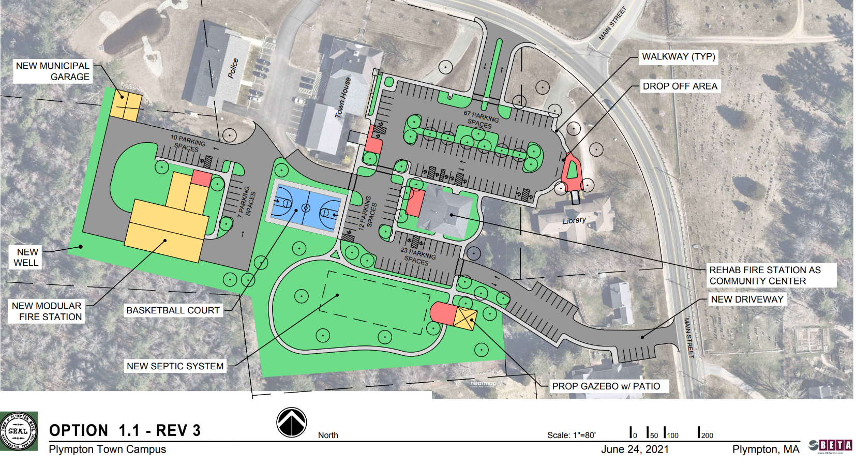
Town Campus Plan - Final Draft - 1.1 REV-3 (1).pdf

Harry Jason Park Possible Clearing (1) for Fields.pdf Harry Jason Park - Possible lay-out of sport
Fields in cleared space

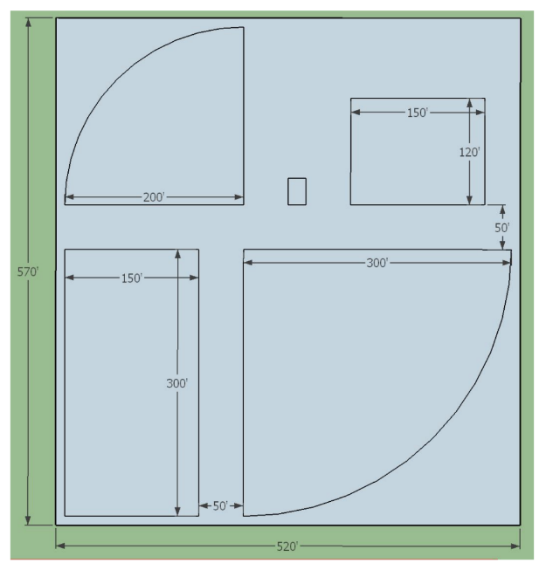
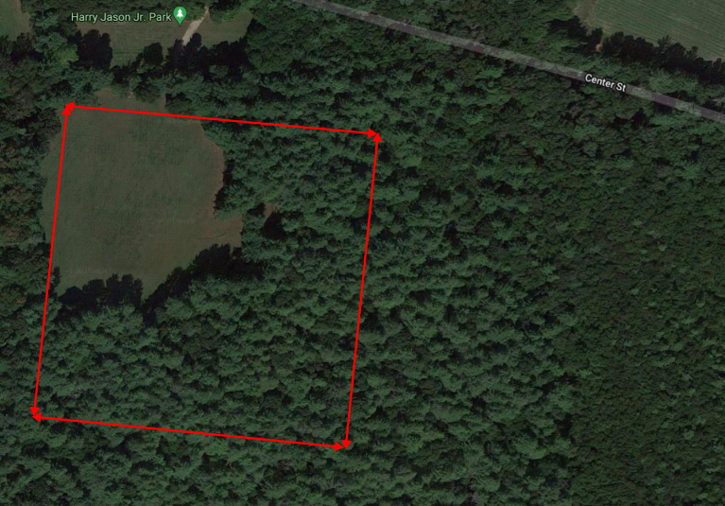

Solar Light on top of flagpole

