PLYMPTON TOWN PROPERTIES COMMITTEE
Minutes March 24, 2021, 6:00 PM
MEMBERS PRESENT: Nancy Butler, Ross MacPherson, Colleen Thompson, John Traynor,
Jon Wilhelmsen (Chair). GUESTS PRESENT: Mark Russo,
NOTES: This meeting was conducted on a Zoom meeting platform with members participating from their homes. Members and guest will be referred to by their initials in the minutes.
ACTION ITEMS: In bold print

- OPENING – JW opened the meeting at 6:06 p.m. by reading the Governor’s orders of 3/12 & 15/20 which allow this Zoom meeting as a temporary change to Open Meeting Law during the COVID-19 shut-down. The meeting will be recorded to provide public access.

- MINUTES: NB moved that the minutes for March 10, 2021 be approved as written. JT seconded. Roll Call Vote: NB aye, JT aye, JW aye, CT aye, RM not yet in meeting.

- TOWN HOUSE [ADA] RAMP UPDATE (see attached) – We received a cost estimate from BETA of $79,000, ($66k Ramp portion, $13k redesigned main entrance). Added to this would be the consulting fees already committed.
Discussion: JW suggests soliciting bids for the ramp portion with the redesigned “Sloping Walk to the Front Door” as an alternate. JT suggests adding the sliding door for the main entrance as a second alternate. Consensus is that we should go ahead with this BETA estimate. There is some concern that materials and construction costs may change. JW will ask BETA to add the door as the second alternate. He will also ask about the planting bed. This is not included in their estimate. If they remove material during construction, it would be best to have it replaced with a good planting medium so that it is ready for landscaping use.

- TOWN MEETING WARRANT ARTICLES FROM THIS COMMITTEE
- JW met with Tom Loughlin of BETA to discuss the numbers for the articles. TL want dimensions of the possible bay or garage to add to the plans. We are working on acquiring those. We should have a number for the Design Services (Town Campus Planning - Phase 2) soon.
- Flag Poles – quote revised down to $5,000.
- Town House Roof – Liz Dennehy will seek numbers for phasing the project.
- JW and RM met with Dan Pallotta of P3 Project Planning Professionals for advice. DP was the Owner’s Project Manager for the Plympton Police Station project. Dan suggests that we build a fire station sooner rather than later. Construction costs will not decrease, a five-to-seven-year delay could mean a substantial increase. Our tax revenues will never increase as quickly as building expenses. Also, interest rates are currently low.

Plympton clearly has issues with the current station. DP suggests we do a warrant article for a fire station feasibility study which would include an evaluation of the existing campus systems and get us to schematic design. This would cost between $300-500k. Some of this work is in process through the Center Campus plans with BETA but there is further need for location, soil, etc. evaluations. DP reminded us that there will be funds coming from the American Rescue Act of 2021 (ARA21) for infrastructure projects. This will be a direct payment to the Town from the federal government with additional funds from the County.
DP suggests that if we do this, we should focus on a company that has done multiple fire stations. There are many specialized conditions and OSHA requirements that would need an experienced company/professional to navigate and allow the creation of a Plympton appropriate building that meets current and future needs and strictures. DP could help us write the RFP. Is this something we should consider for this year?
Discussion: There was discussion around whether we should move forward with this or just stick with our original plan. DP has made some good points and members of this committee have confidence in his advice. In addition to his professional experience, DP has worked in town and county government for many years. He knows how to get stuff done and was a great asset to the Town for the Police Station. JT would like to see a map of all of our projects and costs. People appreciate our First Responders and have seen the extra effort they have given to the Town during this COVID-19 crisis. There will be people who will speak against a new fire station but there are many who will support it. This would be a big campaign with educational sessions, materials, mailers, and a website. JT suggests that we dedicate an entire meeting to the fire station and possible funding.

Bottom Line: JW recommended, and the Committee agreed to put a place holder on the Warrant for this feasibility study and design article. It would be up to the BOS to make the final decision.

- TOWN BARN ROOF – No update.

- DENNETT SCHOOL – Two upcoming capital projects: (1) Sprinkler system cistern work to be done in April, (2) Paving/resealing/striping entrance road and parking lots. Adding some extra parking spaces. These items will not come to this Committee because they can be funded with CARES Act monies and monies unspent from the previous school budget (extra savings from VocTech and SPEDS will fund these projects and still return $90±k to the Town). JW will meet with Principal Peter Veneto and SLRSD Facilities Director Matt Durkee to review other upcoming capital projects.

- OTHER TOWN OWNED PROPERTIES – Town Administrator Liz Dennehy sent another list of properties for review by this Committee (see attached). The BOS would like to know if there is any interest in a particular parcel(s), and our thoughts as to why we might want to hold or sell certain parcels. They would like our response by May 3, 2021.
Discussion: Members will need time to review these parcels. We would like to create a large map of Plympton showing the lot lines so that we can color code the parcels to create an overview to aid in making decisions. Consensus is that we do not want to create larger parcels that become buildable lots or allow access to privately owned lots waiting for the opportunity to build large housing developments. Would the sale of any lot increase tax revenue? Building housing is a net loss to the Town unless it is for seniors.

- NEXT MEETING: TBD

- ADJOURNMENT: 7:24 NB moved; JT seconded

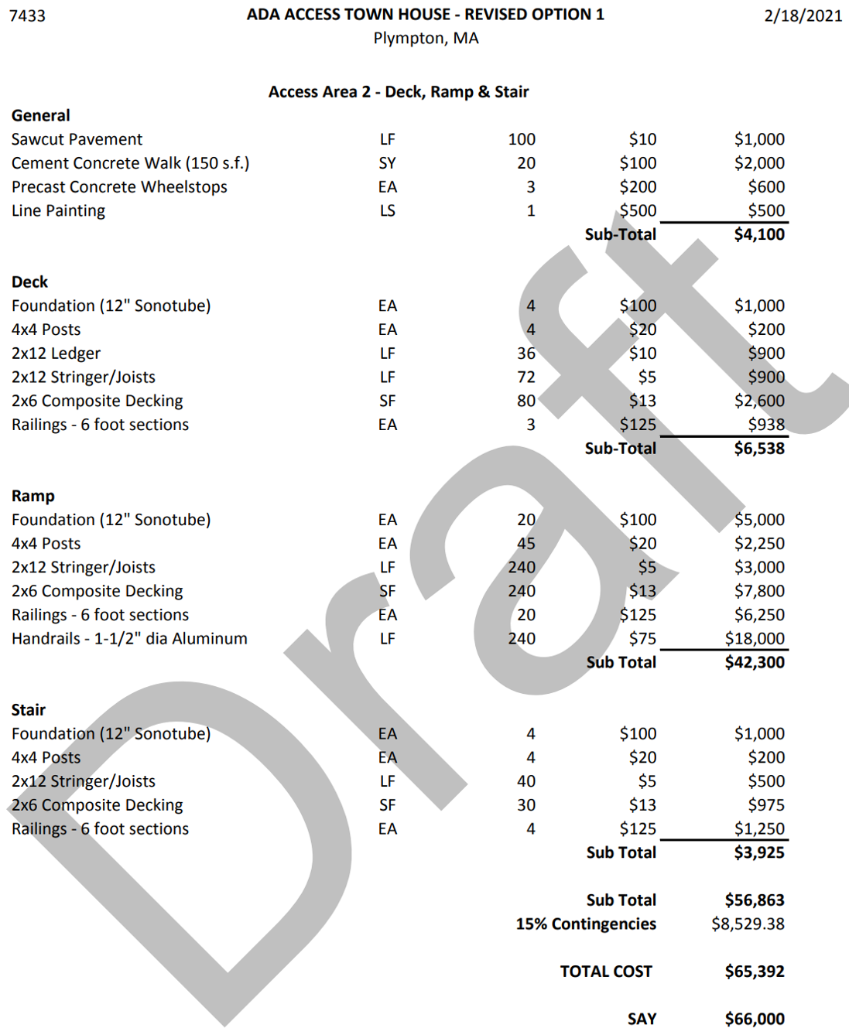
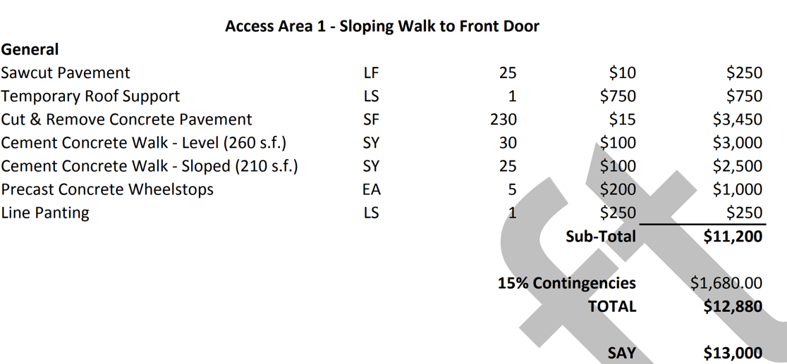

FROM LIZ DENNEHY / BOS

Town-owned land on the books (Town-owned and also the 2019 tax takings). As per the processed established by the BOS for disposition of Town-owned land, can your Committee please review this information and let me know if there is any interest in a particular parcel(s). Additionally, if you have thoughts as to why we might want to hold or sell certain parcels, feel free to voice those opinions, as well. If I could have this information back to me by May 3, 2021, it would be much appreciated. If we do not hear back from your Board/Committee on or before May 3, 2021, we will consider it as though you did not have any comments.

2019 tax takings recorded 12/23/20, can proceed to foreclosure after 6 months redemption period

Bryant, 16-3-20 and 16-3-23, Elm Street, will be Land of Low Value foreclosure through the DOR

Bricknell, 7-1-34, Maple Street, previously auctioned had to redo because of title issue, several abutters interested, Land of Low Value foreclosure through DOR

Colton, 1-3-12, Grove Street, I have letters that he and his heirs would give land to town, not worth anything to anyone but abutter/Donovan. Land of Low Value, foreclosure through the DOR

Justice, 7-2-25 and 7-2-14, Maple Street, heirs tried to perk to no avail, Land of Low Value foreclosure through DOR

Pillsbury, 16-3-25, Elm Street, value over $22,862 DOR value limit so will be a land court foreclosure

Deming, 11-1-13, Center Street, heir wants to give this to the town, abuts Harry Jason Park, will be a land court foreclosure.

Schatzl, 23-3-20, Prospect Road, will be Land of Low Value foreclosure through DOR

Templon, 4-1-14-A, Main Street, will be a land court foreclosure.

Rick Springer is waiting for our already town owned parcel on Churchill Road to go to auction. He owns the abutting lot and needs ours in order to build a home.

Doherty, 16-3-5, 38 West Street is in tax title with a 2nd agreement to pay, again in default and Atty Coppola just sent a letter threatening foreclosure if he is not brought up to date

We have one parcel owned by Piscionere c/o Sideliner, 4-3-17 to be left in tax title and not put in foreclosure because the land is contaminated

